

## Visual Programming Project Report

**Title: Air University Student Portal Registration System (AUSPRS)**

### Group members:

Saad Khan Ayesha Mudassar Tania Khawar

Maaz Zulfiqar

### Submitted to

Sir Tariq Mehmood

### Submission Date:

31/5/2025

### Table of Content:

1. Problems and Solutions
2. Members contribution
3. Introduction
4. Figma Design
5. Database Schema
6. Key Features
   1. Login Page
   2. AI Integration
   3. Notepad Page
   4. Timetable Page
   5. Home Activities Page
   6. Course Guidebooks Page
   7. Past Papers Page
   8. Complaints Page
   9. Announcements Page
   10. Google Classroom
   11. Dictionary Integration
7. Data Management and Connectivity
8. Mobile Application Development: Top 10 Factors to Consider
9. Screenshots of AirAcademia

## Real-Life Problems and the Solutions Provided by the Project

#### Problem 1: Lack of a Centralized Student Portal

* **Real Issue:** In most universities, students must access multiple disconnected platforms (email for announcements, paper forms for leaves, Excel sheets for attendance, etc.). This leads to confusion, missed deadlines, and poor student engagement.
* **Solution Provided by the Project:**
  + A unified portal that brings together attendance, societies, announcements, assignments, feedback, course registration, and more into **one modern web interface**.

#### Problem 2: Inefficient, Manual Leave & Attendance System

* **Real Issue:** Students physically go to staff rooms with paper leave forms, which is stressful and time-consuming—especially when sick or away.
* **Solution Provided by the Project:**
  + A digital Leave Request & Attendance Justification page with document upload, status tracking, and auto-adjustment request for missed attendance.

#### Problem 4: Confusion in Course Selection and Registration

* **Real Issue:** Students often pick wrong courses, miss prerequisites, or are unaware of which electives they’re eligible for.
* **Solution Provided by the Project:**
  + A smart course selection system with dynamic filters, prerequisite checks, and eligibility logic for hassle-free registration.

#### Problem 5: Missed Opportunities Due to Lack of Awareness

* **Real Issue:** Students miss internships, exchange programs, and events because they don’t know what’s available or when to apply.
* **Solution Provided by the Project:**
  + A centralized platform for job/internship listings, international program details, and a calendar/announcement system to keep students informed.

#### Problem 6: No Direct Communication with Advisors or Admin

* **Real Issue:** Students face academic issues but don’t know whom to contact or how.
* **Solution Provided by the Project:**
  + Integrated Inbox and Chat System for communication with advisors or admin— bringing real-time help within reach.

#### Problem 7: Difficulty Updating and Managing Student Information

* **Real Issue:** Students can't easily update their profile info (email, phone, documents), causing outdated records.
* **Solution Provided by the Project:**
  + A Profile Management page where students can edit their personal, academic, and contact details with ease.

#### Problem 8: No Feedback or Complaint Mechanism

* **Real Issue:** Students have no structured, anonymous way to give feedback on courses or report issues.
* **Solution Provided by the Project:**
  + A Feedback & Complaints page that allows students to safely voice their concerns and suggest improvements.

### Group member contribution:

|  |  |  |  |
| --- | --- | --- | --- |
| **Muhammad Saad Khan** | **Ayesha Mudassar** | **Tania Khawar** | **Maaz Zulfiqar** |
| **User**  **Authentication database Firestore using firebase** | **Dynamic Calender and backend for leave and attendance page** | **Real time Chat Hub Inbox** | **Post-Graduate and Under-Graduate page with backend connected to Google Cloud store** |
| **API Chatgpt and SSMS for backend Database** | **Announcement Page** | **Course registration and Backend with Firestore Analytics** | **Student Exchange & International Programs**  **connected to Javascript Backend for pdf handling** |
| **Internship and Jobs with**  **firebase** | **Socities And Clubs** | **Feedback and Complaints and backend** | **Contact Us and Backend** |
| **Home and Login Page with Splash Screen** | **Integration of Real time talk through**  **Microsoft AspNetCore**  **SignalR Client** | **FAQ page** | **Integration of Real time talk through Microsoft AspNetCore**  **SignalR Client** |
| **Registration page and backend with SQL server**  **using CRUD operation** | **Nav Bar and Profile Setup** | **Student Dashboard with Javascript** | **Student Dashboard with Javascript** |

|  |  |  |  |
| --- | --- | --- | --- |
| **SSMS for Backend** | **SSMS for backend** | **SSMS for backend** | **SSMS for Backend** |

**Introduction**

In today's digital age, universities require comprehensive platforms to manage both academic and extracurricular activities efficiently. "Air University Student Portal Registration System" is a mobile and web-based application designed to serve as a one-stop solution for students. It simplifies student life by consolidating academic resources, communication tools, real-time chat, AI integration, and feedback mechanisms into a single robust platform.

### Project Overview

The app features a centralized dashboard allowing access to GPA tracking, academic resources, and real-time updates. Students can register for courses, clubs, and internships using dynamic forms backed by SQL Server and Firebase. Real- time chat functionality using SignalR, integration of ChatGPT for AI-driven support, and modern UI/UX with Razor components make this app a future-ready solution tailored to Air University students.

### Web Application Development: Top 10 Factors Considered

During the development of the Air University Student Portal, the following critical factors were addressed to ensure a seamless and efficient process:

1. **Research**
   * Conducted surveys and interviews with students and faculty to identify pain points.
   * Prioritized features like centralized dashboards, automated attendance, and real-time chat based on feedback.
2. **Target Audience**
   * Tailored the app exclusively for Air University students and staff.
   * Addressed academic needs (GPA tracking, course registration) and extracurricular management (clubs, internships).
3. **Platform Selection**
   * Chose Flutter (Dart) for cross-platform compatibility (Android/iOS) and a consistent UI.
   * Backend powered by Firebase (scalability) and SQL Server (structured data).
4. **Plan of Action**
   * Created a roadmap with milestones:
     + Phase 1: Authentication + Dashboard (Weeks 1–3).
     + Phase 2: Course Registration + Chat (Weeks 4–6).
     + Phase 3: Testing + Deployment (Weeks 7–8).
   * Held weekly reviews to track progress.
5. **Budget Management**
   * Leveraged open-source tools (Firebase, SignalR) to minimize costs.
   * Allocated resources to critical features (AI integration, real-time chat).
6. **Innovation**
   * Integrated ChatGPT API for AI-driven student support.
   * Combined 10+ functionalities (attendance, jobs, clubs) into one platform.
7. **Performance & Efficiency**
   * Optimized UI with Razor Pages and JavaScript for fast load times.
   * Implemented caching for frequently accessed data (announcements, GPA).
8. **User Experience (UX)**
   * Designed intuitive interfaces with role-based dashboards (student/admin).
   * Tested prototypes with 50+ students to refine navigation.
9. **Marketing Strategy**
   * Planned launch via:
     + University emails and social media (Facebook, LinkedIn).
     + On-campus workshops to demo features.
10. **Testing & Quality Assurance**
    * Conducted:
      + Functional tests: Verified CRUD operations (SQL Server).
      + Performance tests: Stress-tested SignalR chat with 100+ concurrent users.
      + User acceptance tests (UAT): Incorporated feedback from beta testers.

### Technologies Used

* + **Firebase**: Authentication and Firestore for real-time database.
  + **SQL Server & SSMS**: Used for CRUD operations and backend data storage.
  + **SignalR & ChatHub**: Enables real-time chat and inbox system.
  + **API Integration**: ChatGPT API for AI interaction and Google Cloud for analytics.
  + **JavaScript/CSS/HTML**: Used for responsive front-end and dynamic components.
  + **C# & Razor Pages**: For modular, maintainable UI using SOLID principles.

**FIGMA DESIGN**

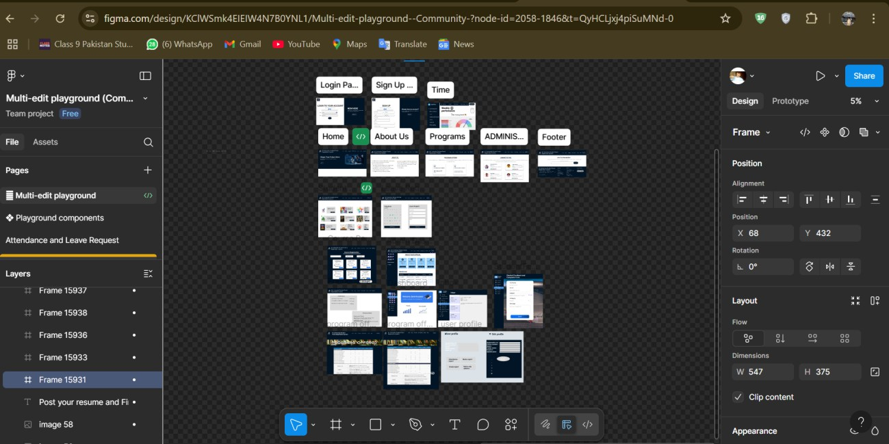

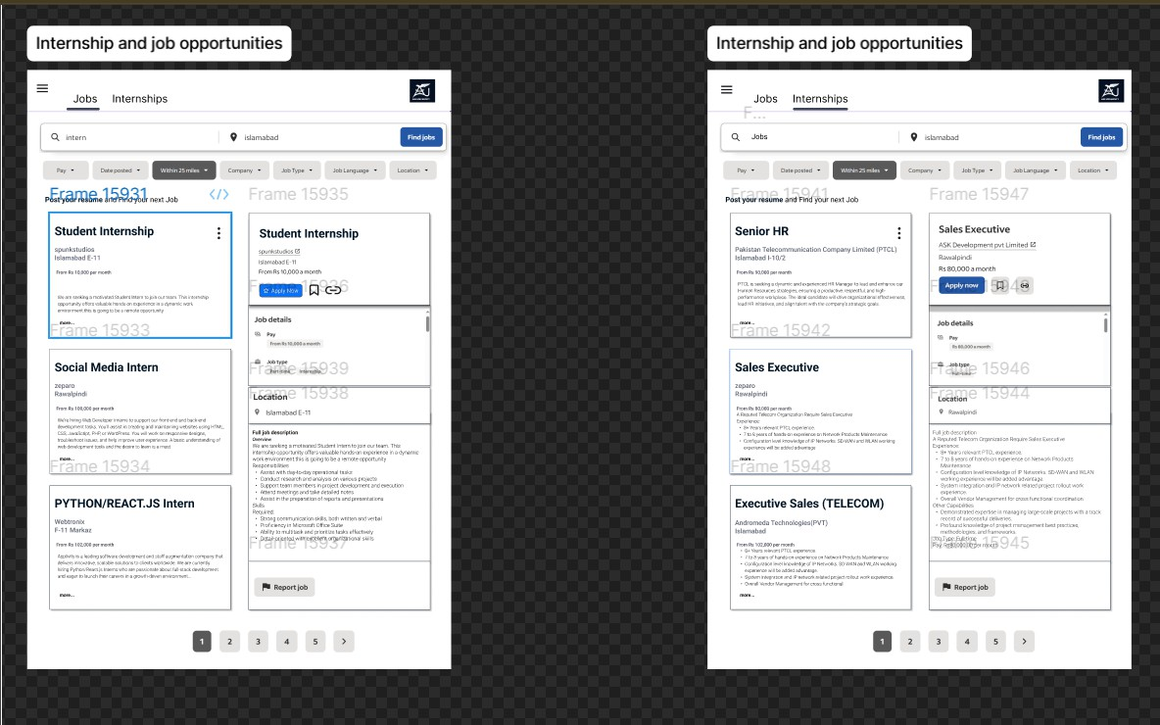

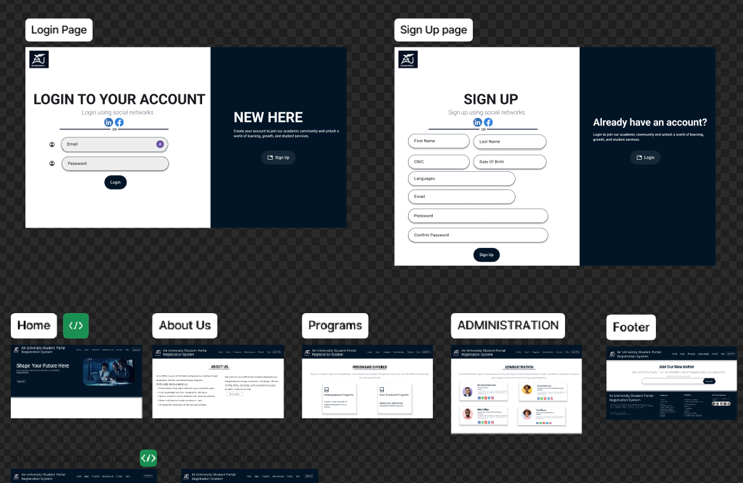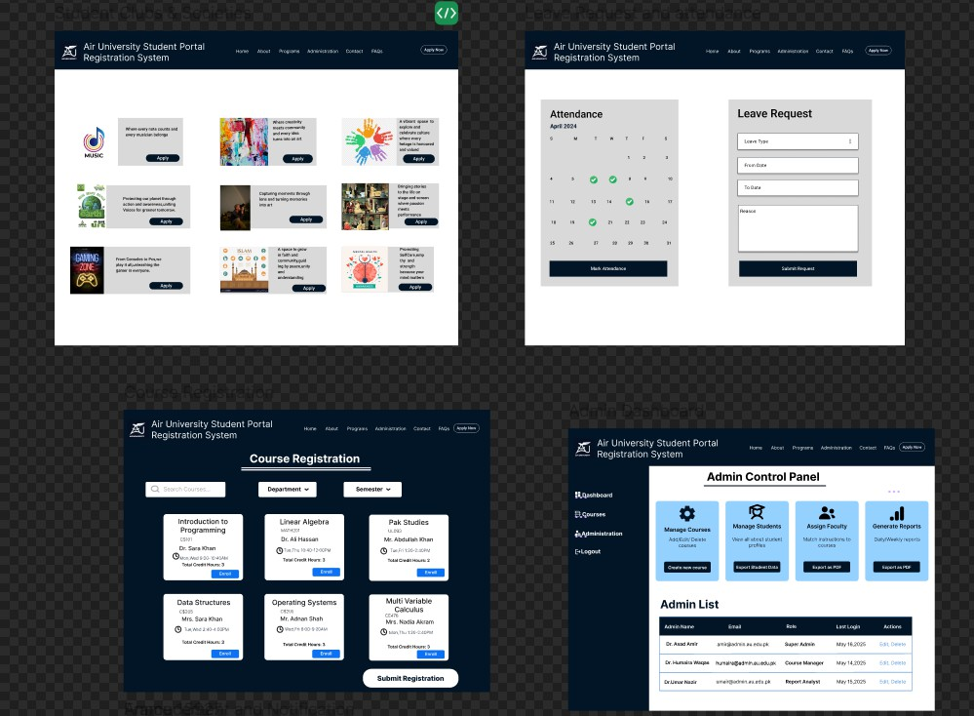

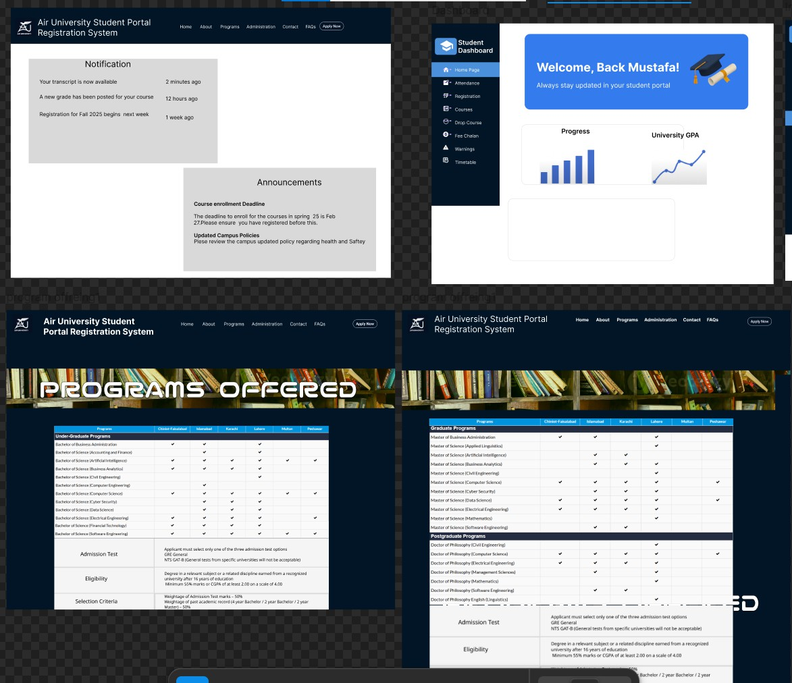

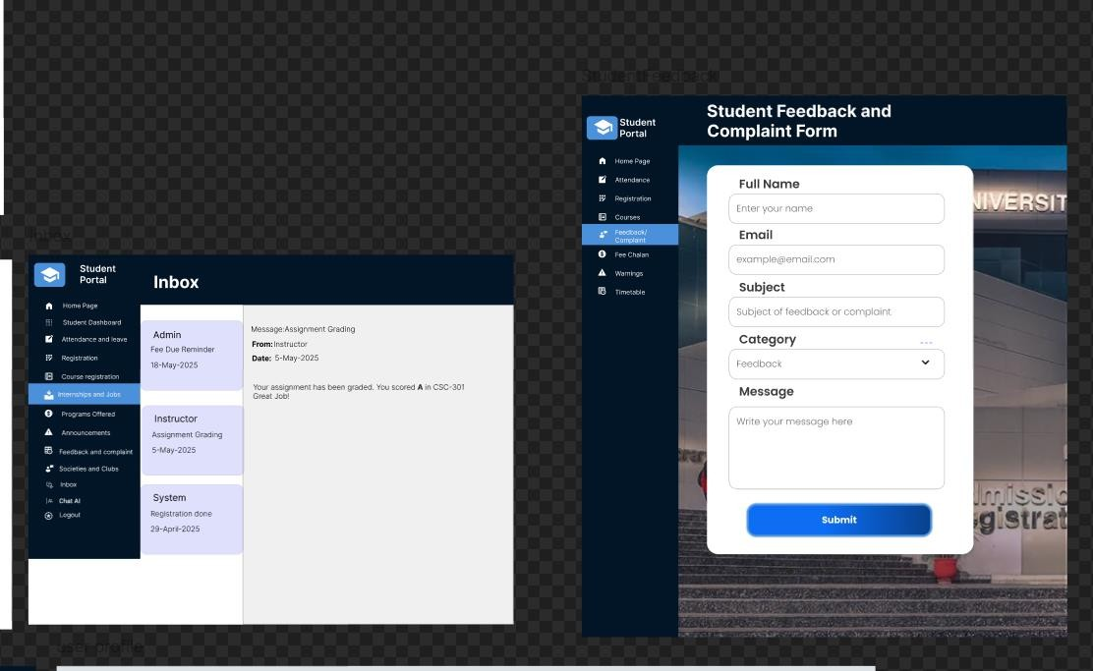

**DATABASE SCHEMA:**

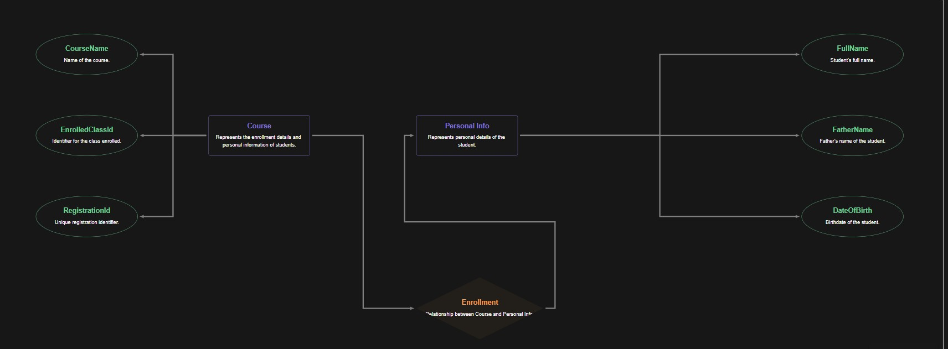

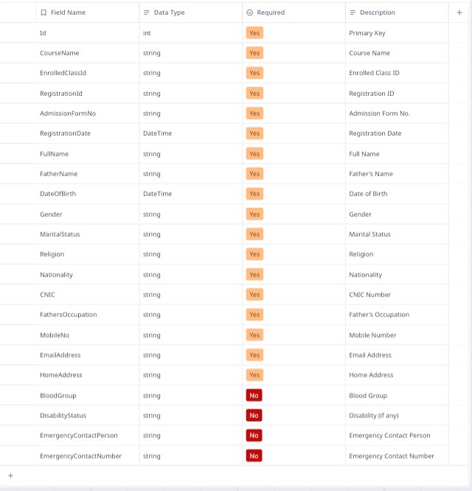**EXPLANATION:**

# Entity-Relationship Diagram (ERD)

This document outlines the structure of the Course class, detailing its attributes and categorizing them into relevant sections. The class is designed to manage course enrollment details, personal information, contact and family information, and additional optional information.

## Entity: Course

#### Primary Key

* **Id**: int

The unique identifier for each course entry.

#### Course Enrollment Details

* **CourseName**: string

The name of the course. (Required)

* **EnrolledClassId**: string

The identifier for the class in which the student is enrolled. (Required)

* **RegistrationId**: string

The registration identifier for the course. (Required)

* **AdmissionFormNo**: string

The admission form number associated with the course enrollment. (Required)

* **RegistrationDate**: DateTime

The date when the registration was completed. (Required)

#### Personal Information

* **FullName**: string

The full name of the student. (Required)

* **FatherName**: string

The name of the student's father. (Required)

* **DateOfBirth**: DateTime

The birth date of the student. (Required)

* **Gender**: string

The gender of the student. (Required)

* **MaritalStatus**: string

The marital status of the student. (Required)

* **Religion**: string

The religion of the student. (Required)

* **Nationality**: string

The nationality of the student. (Required)

* **CNIC**: string

The Computerized National Identity Card number of the student. (Required)

#### Contact & Family Info

* **FathersOccupation**: string

The occupation of the student's father. (Required)

* **MobileNo**: string

The mobile number of the student. (Required)

* **EmailAddress**: string

The email address of the student. (Required)

* **HomeAddress**: string

The home address of the student. (Required)

#### Additional Info (Optional)

* **BloodGroup**: string?

The blood group of the student. (Optional)

* **DisabilityStatus**: string?

Information about any disabilities the student may have. (Optional)

* **EmergencyContactPerson**: string?

The name of the emergency contact person. (Optional)

* **EmergencyContactNumber**: string?

The contact number for emergencies. (Optional)

This ERD provides a comprehensive overview of the Course class, capturing all necessary attributes for managing course-related data efficiently.

**Screenshots:**

1. **HOME PAGE:**



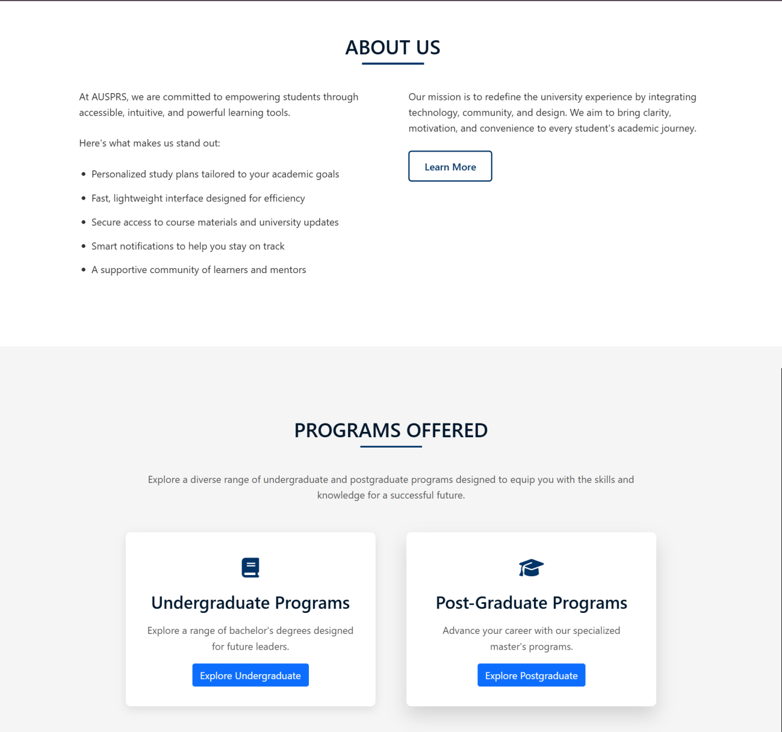

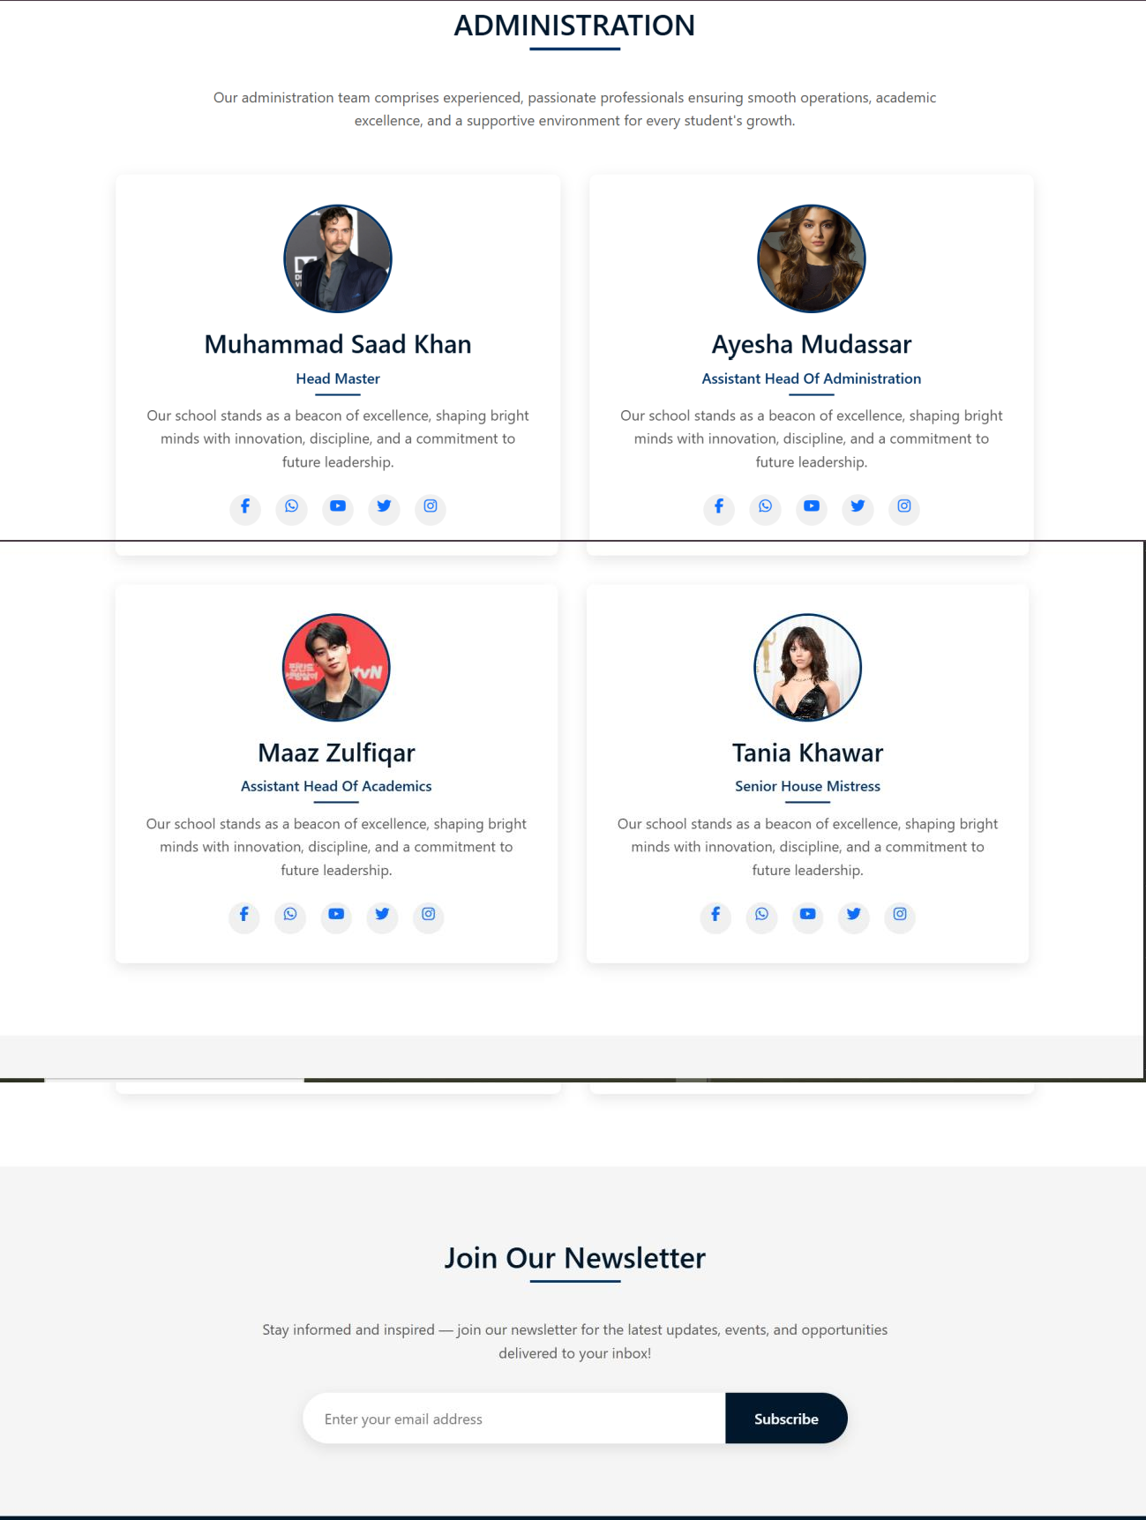

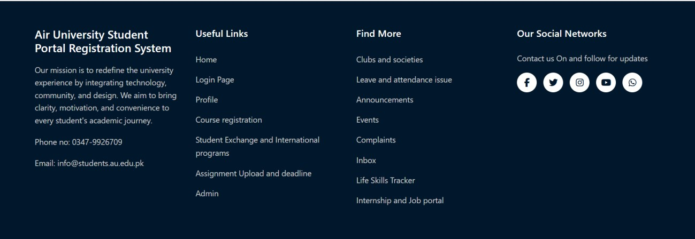

1. **LOGIN PAGE**

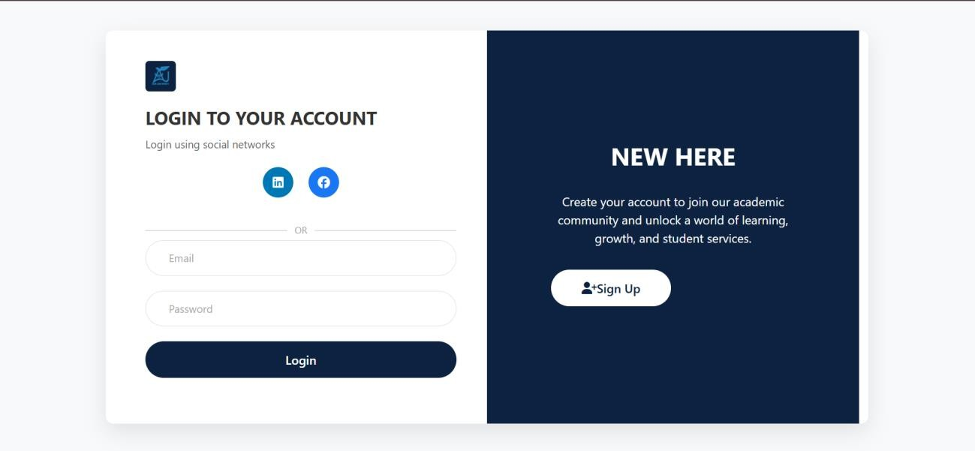

1. **SIGN UP PAGE**

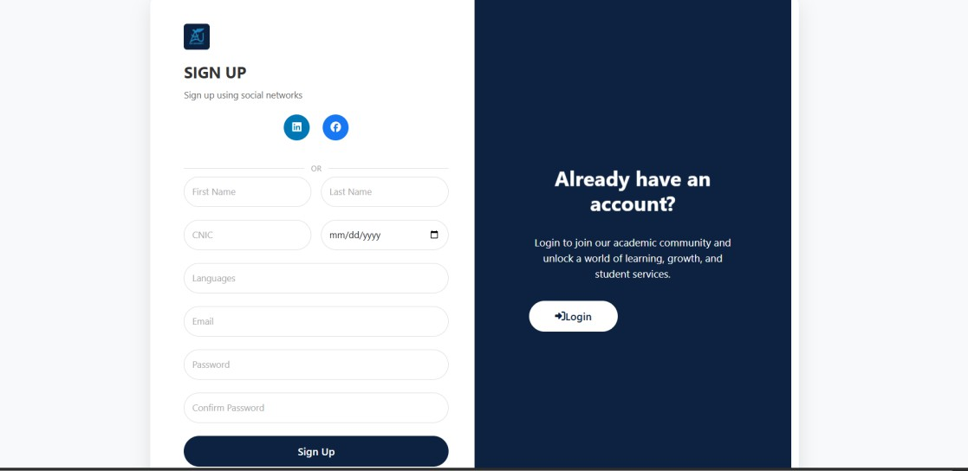

1. 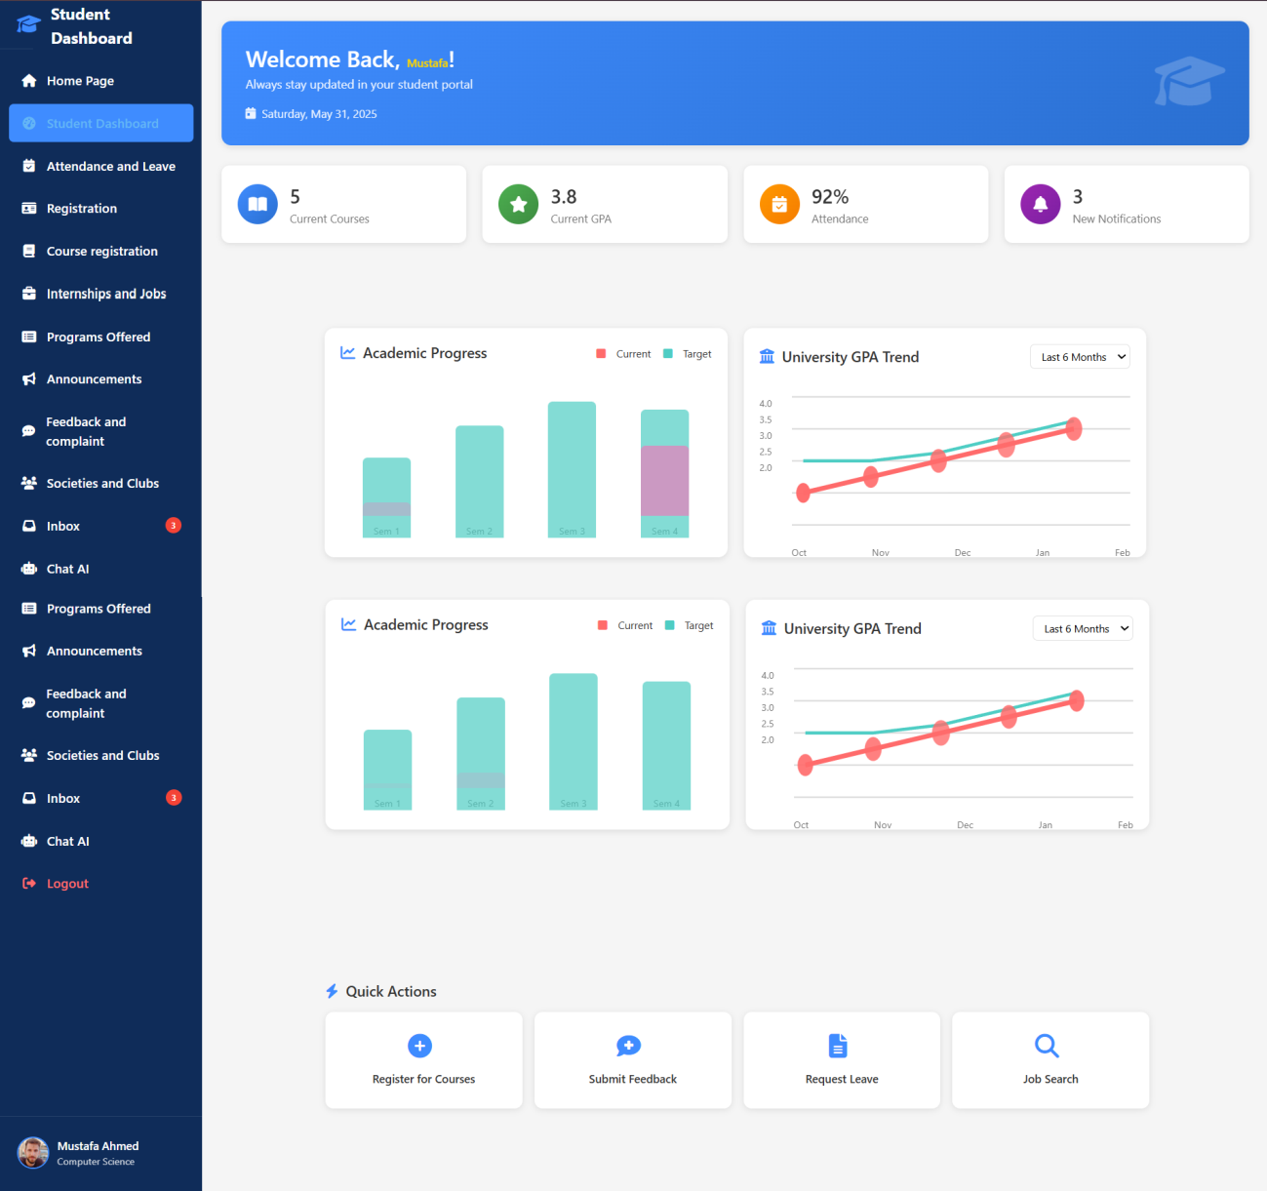**Student Dashboard:**
2. 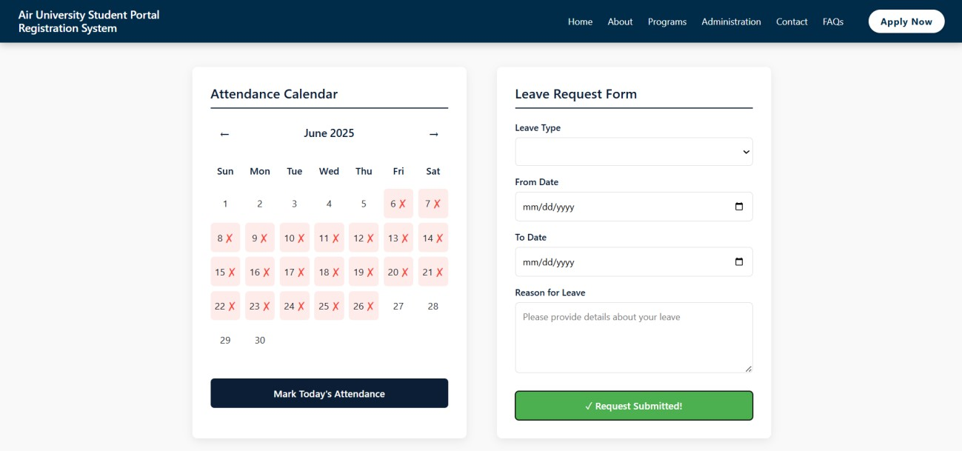**Attendance and Leave Portal**
3. **Registration:**

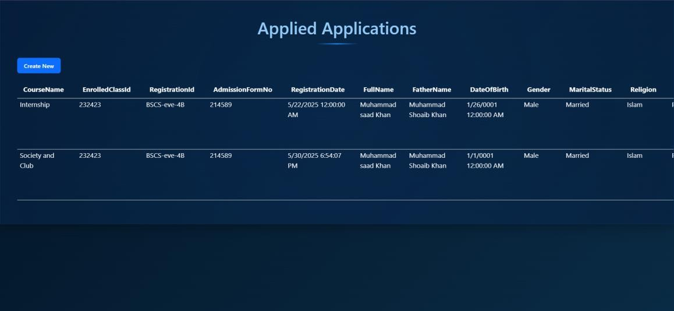

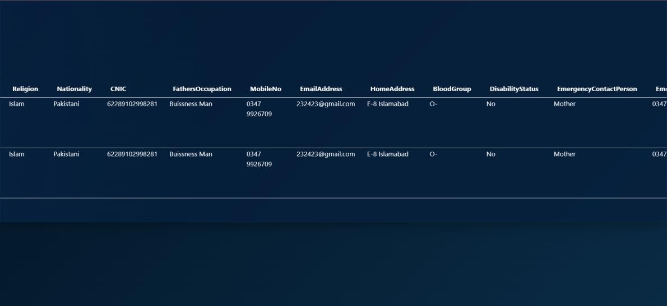

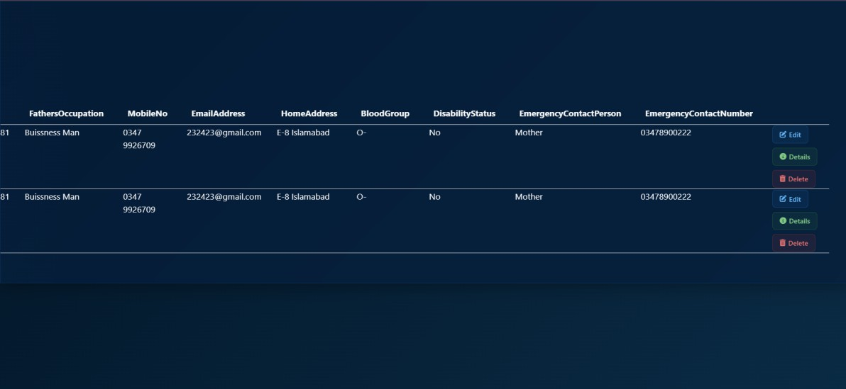

1. **Create:**

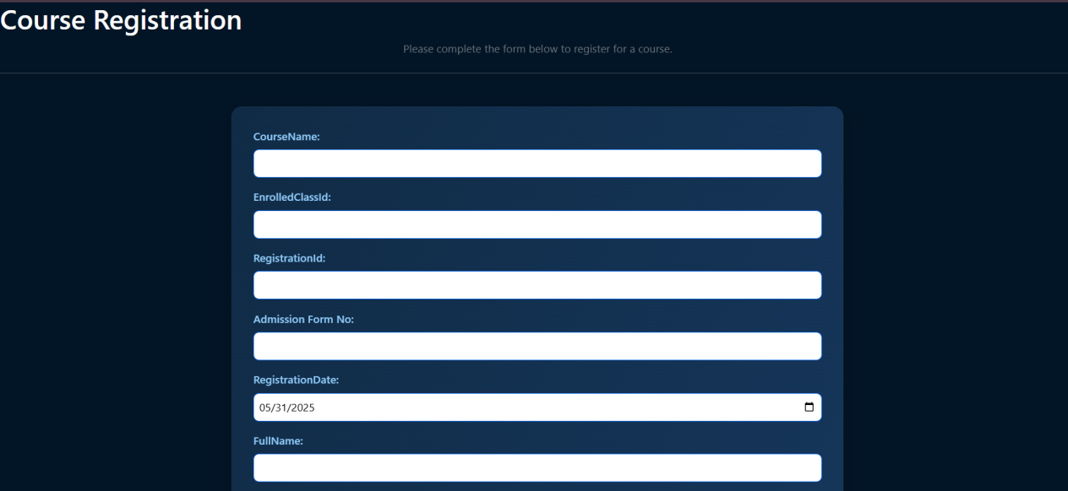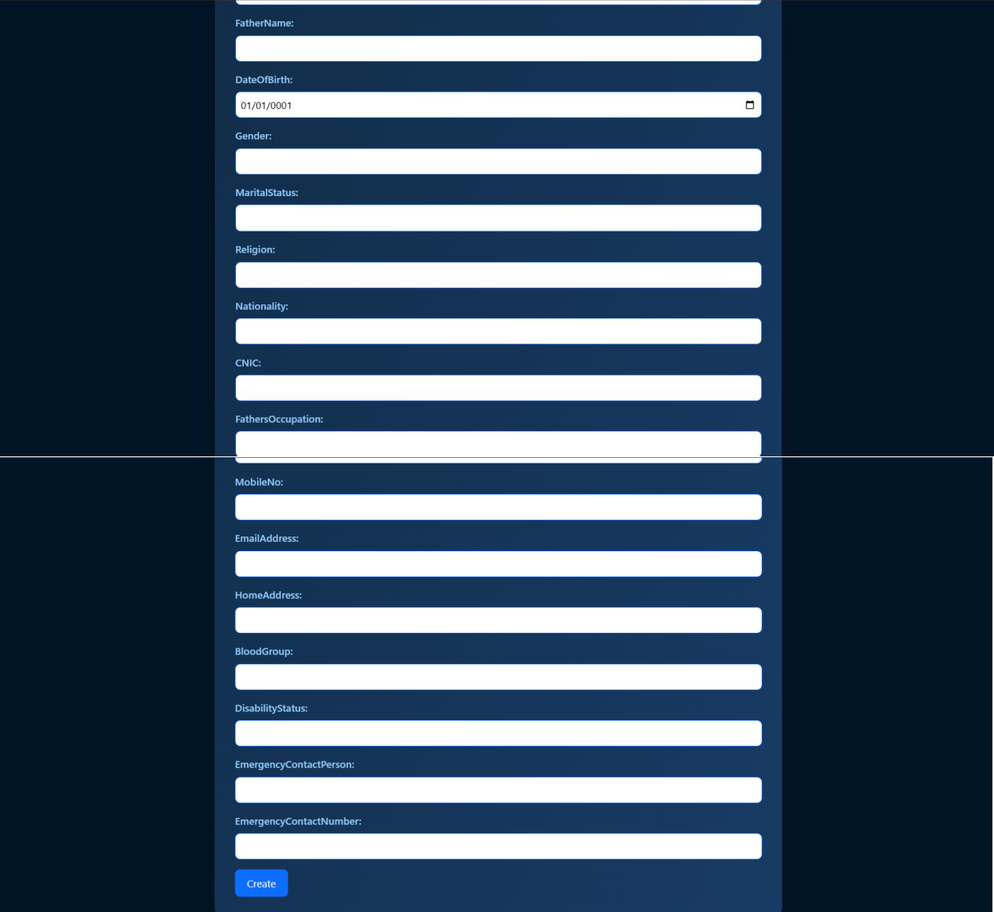

1. 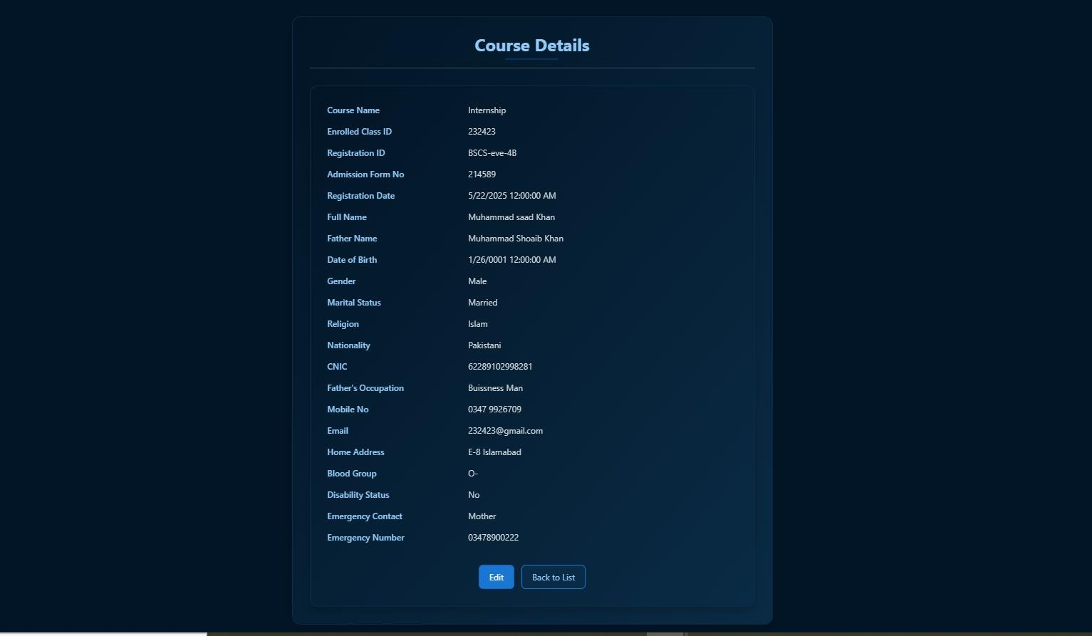**Details:**
2. 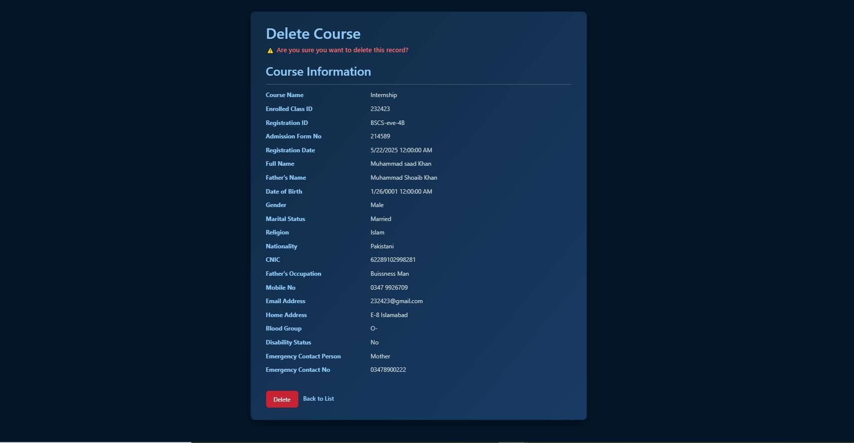**DELETE:**
3. **EDIT:**

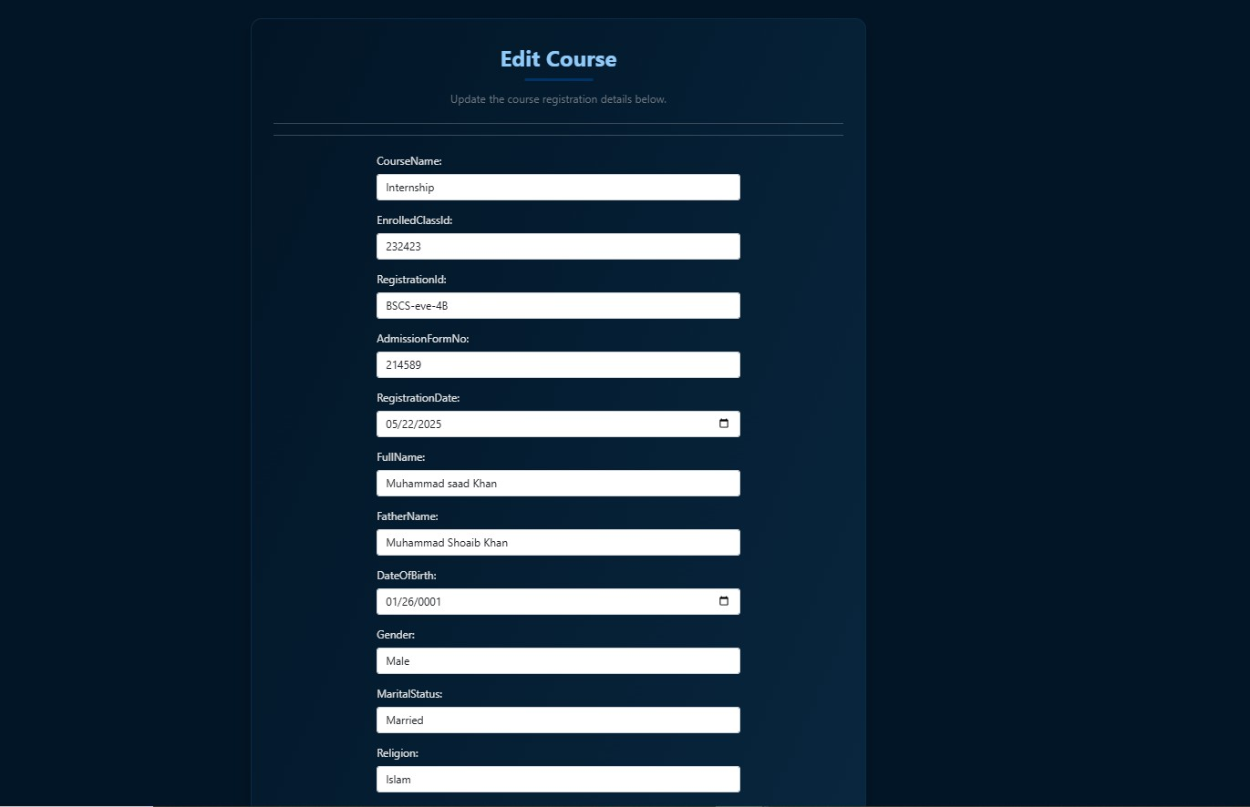

1. **COURSE REGISTRATION:**

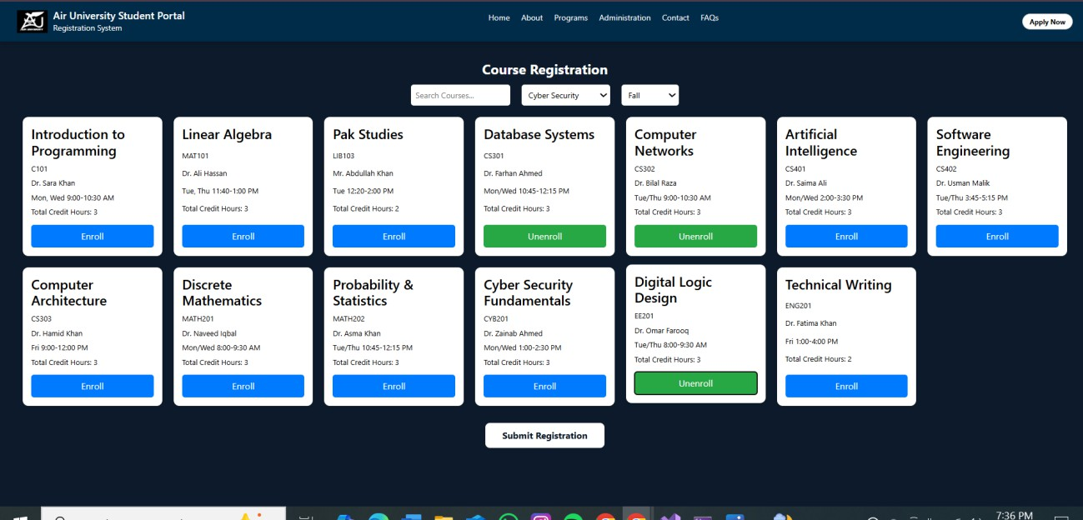

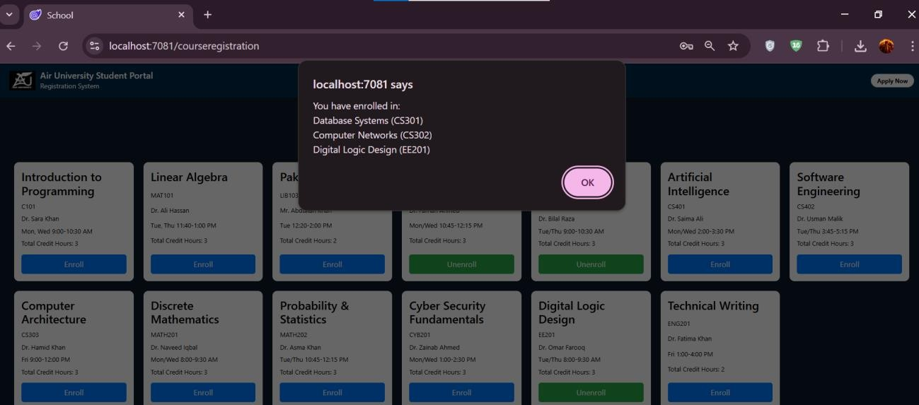

1. **INTERNSHIPS and JOBS**

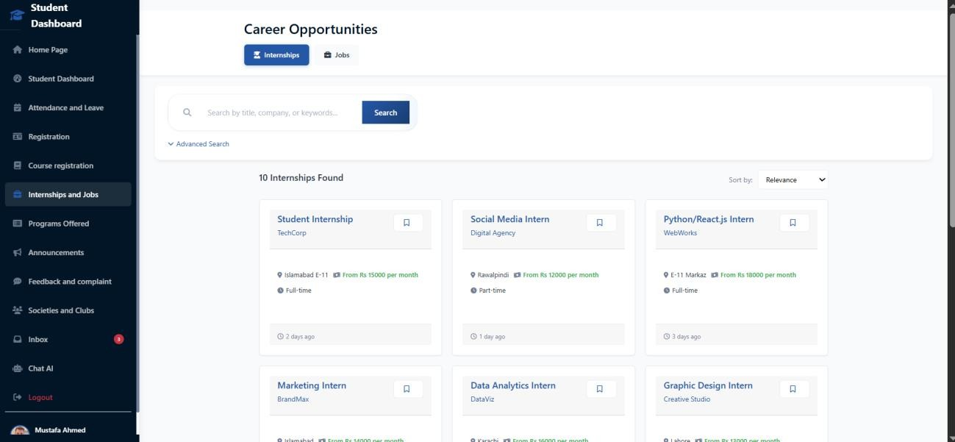

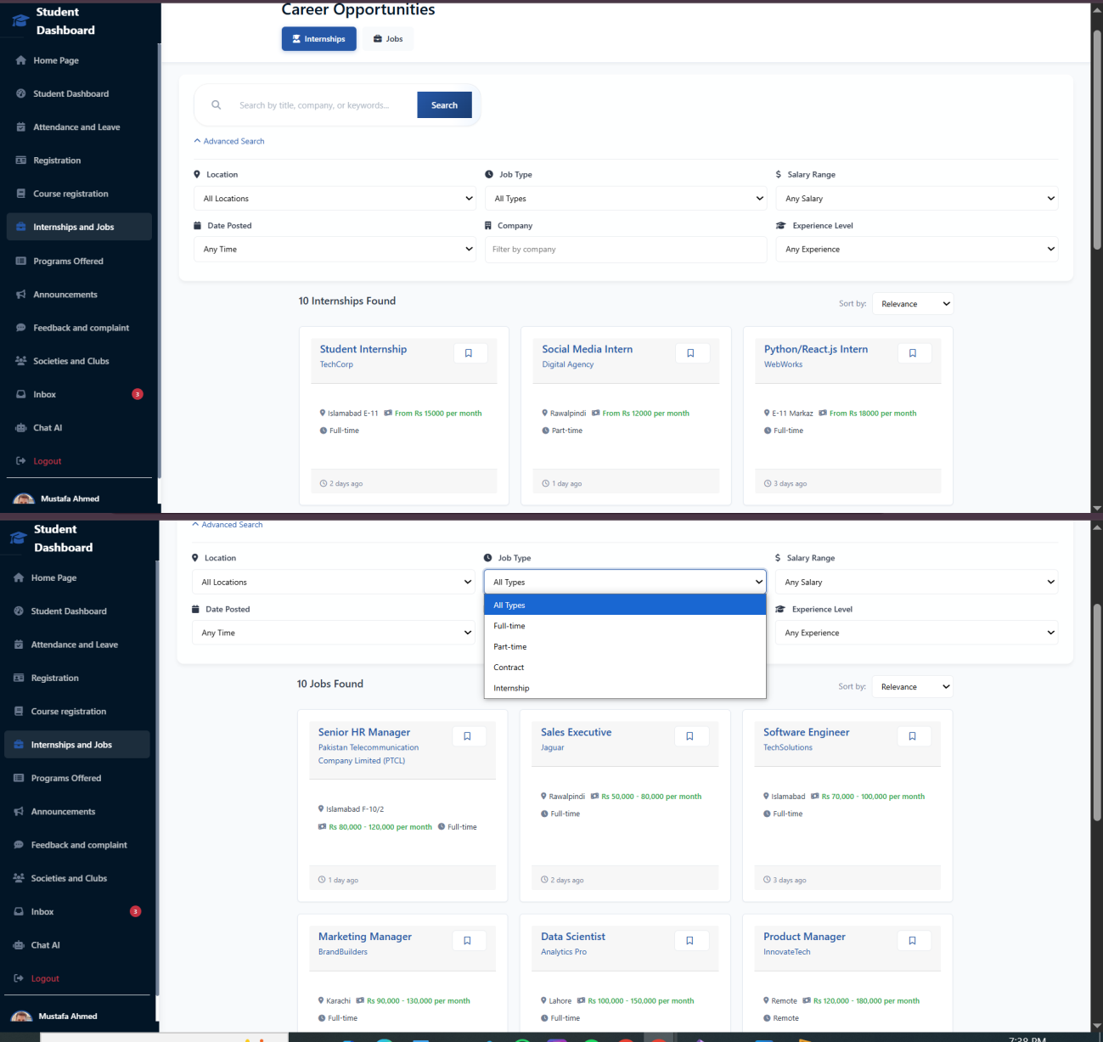

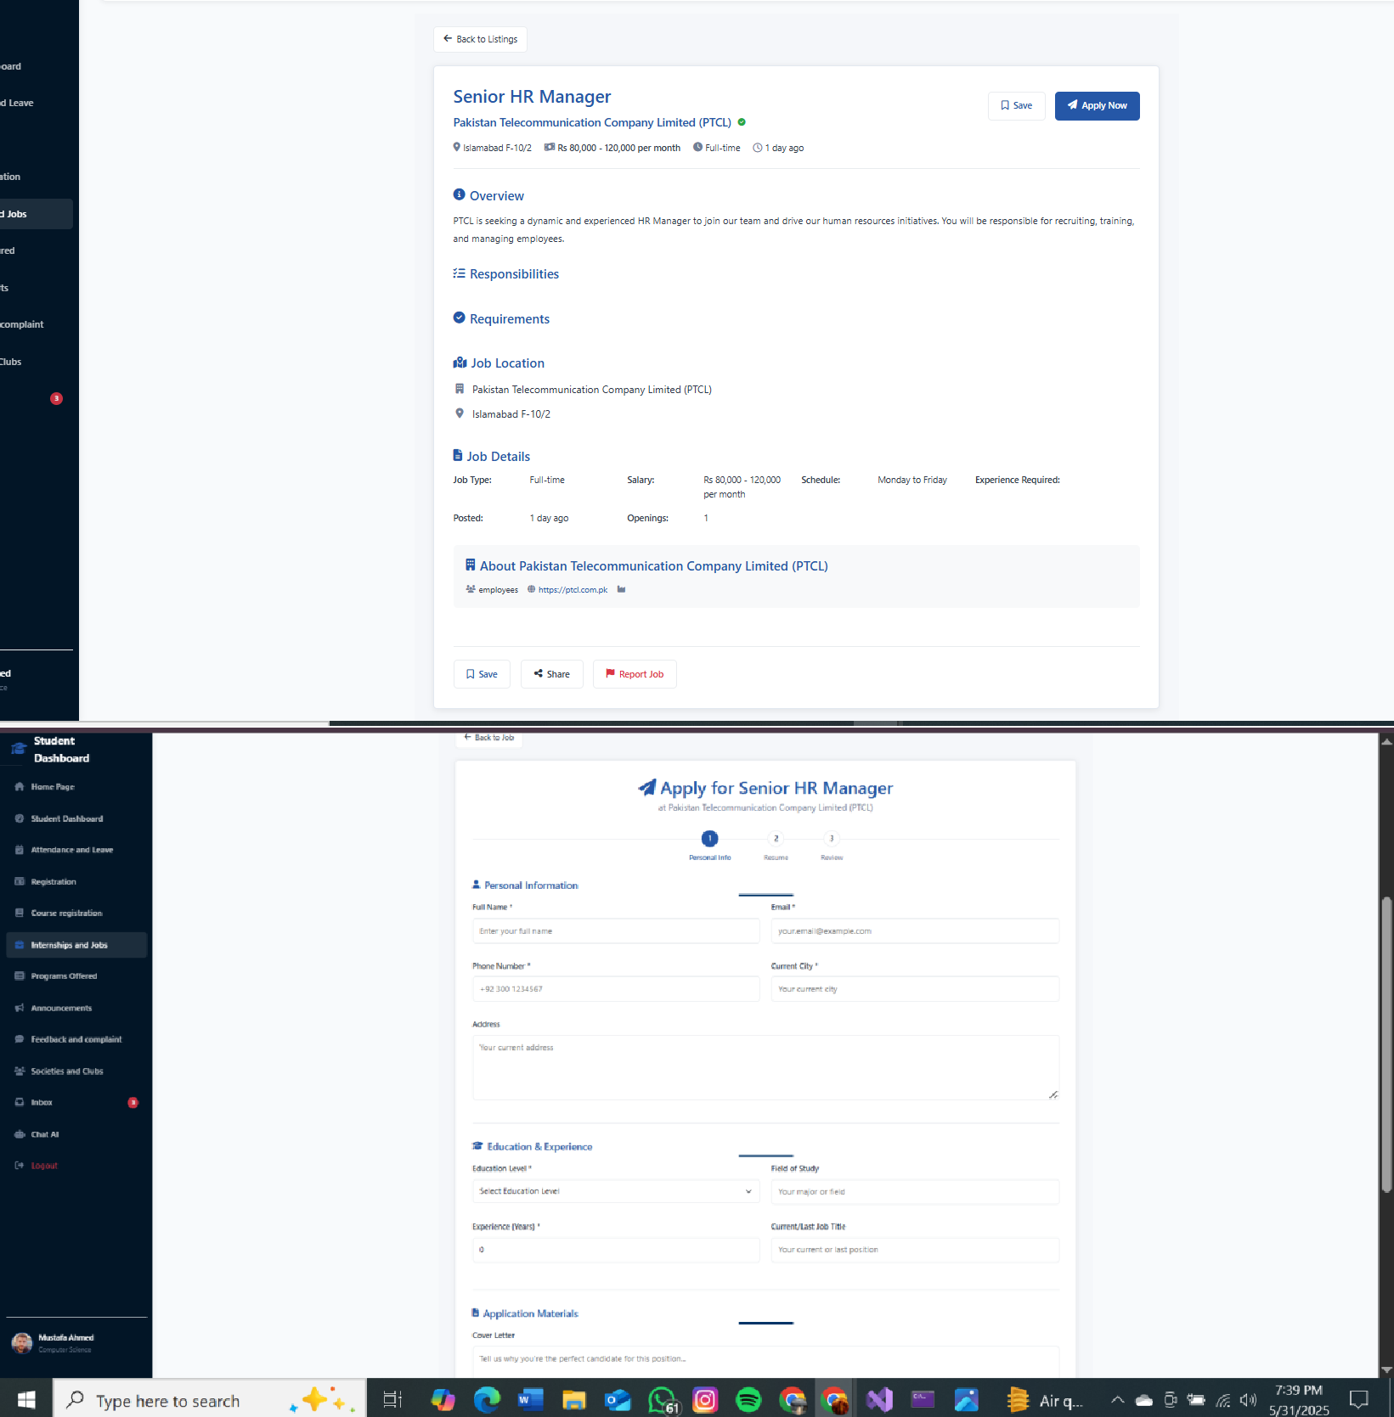

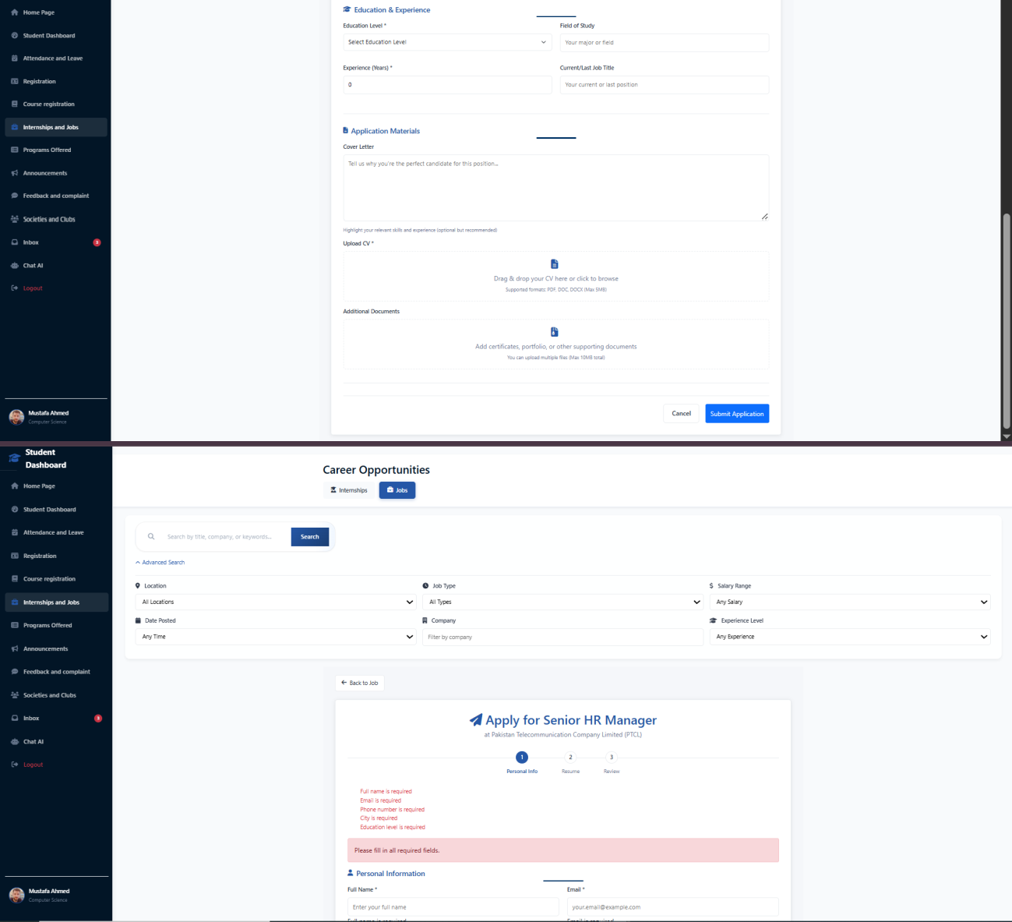

1. **Programs Offered:**

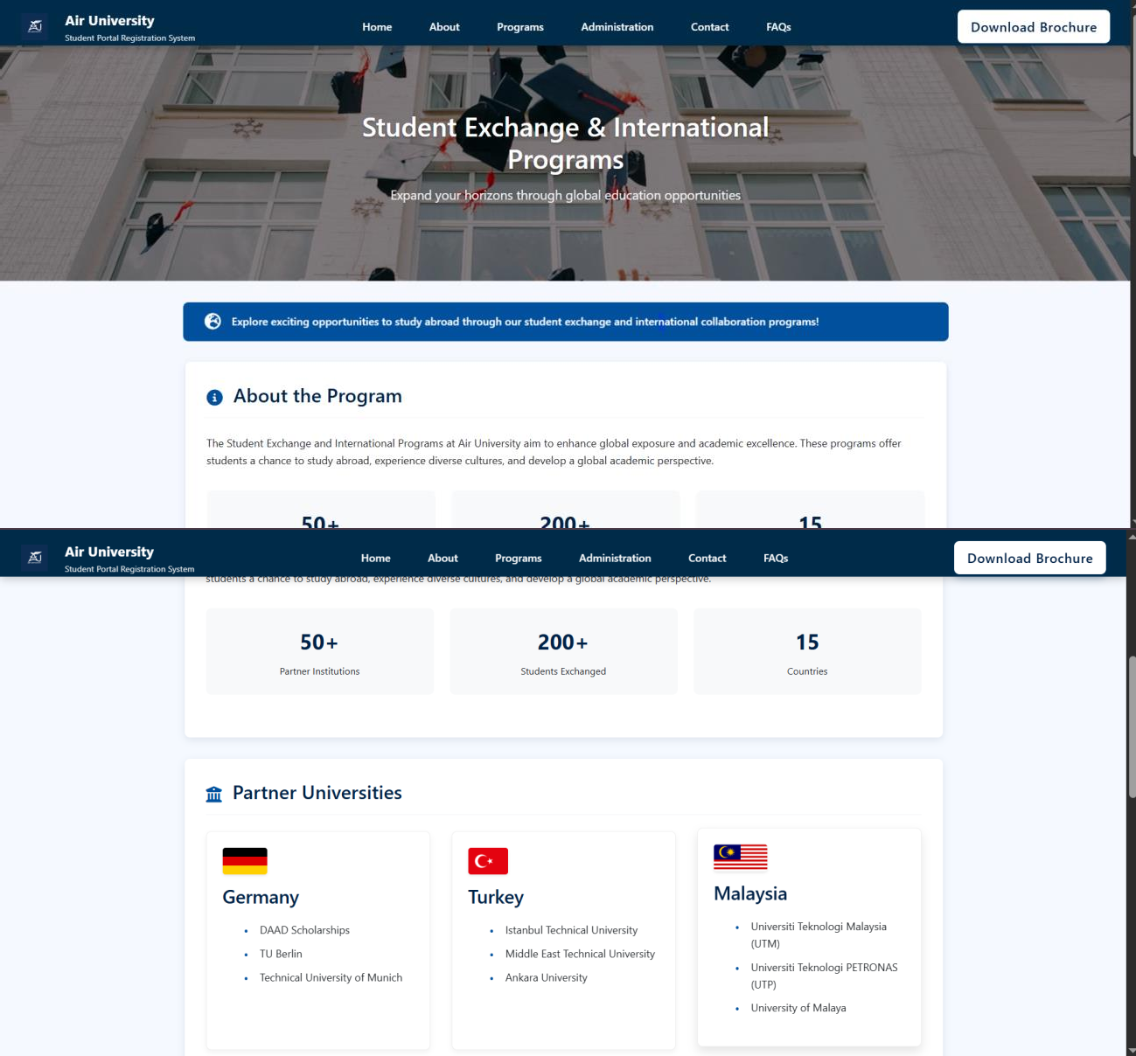

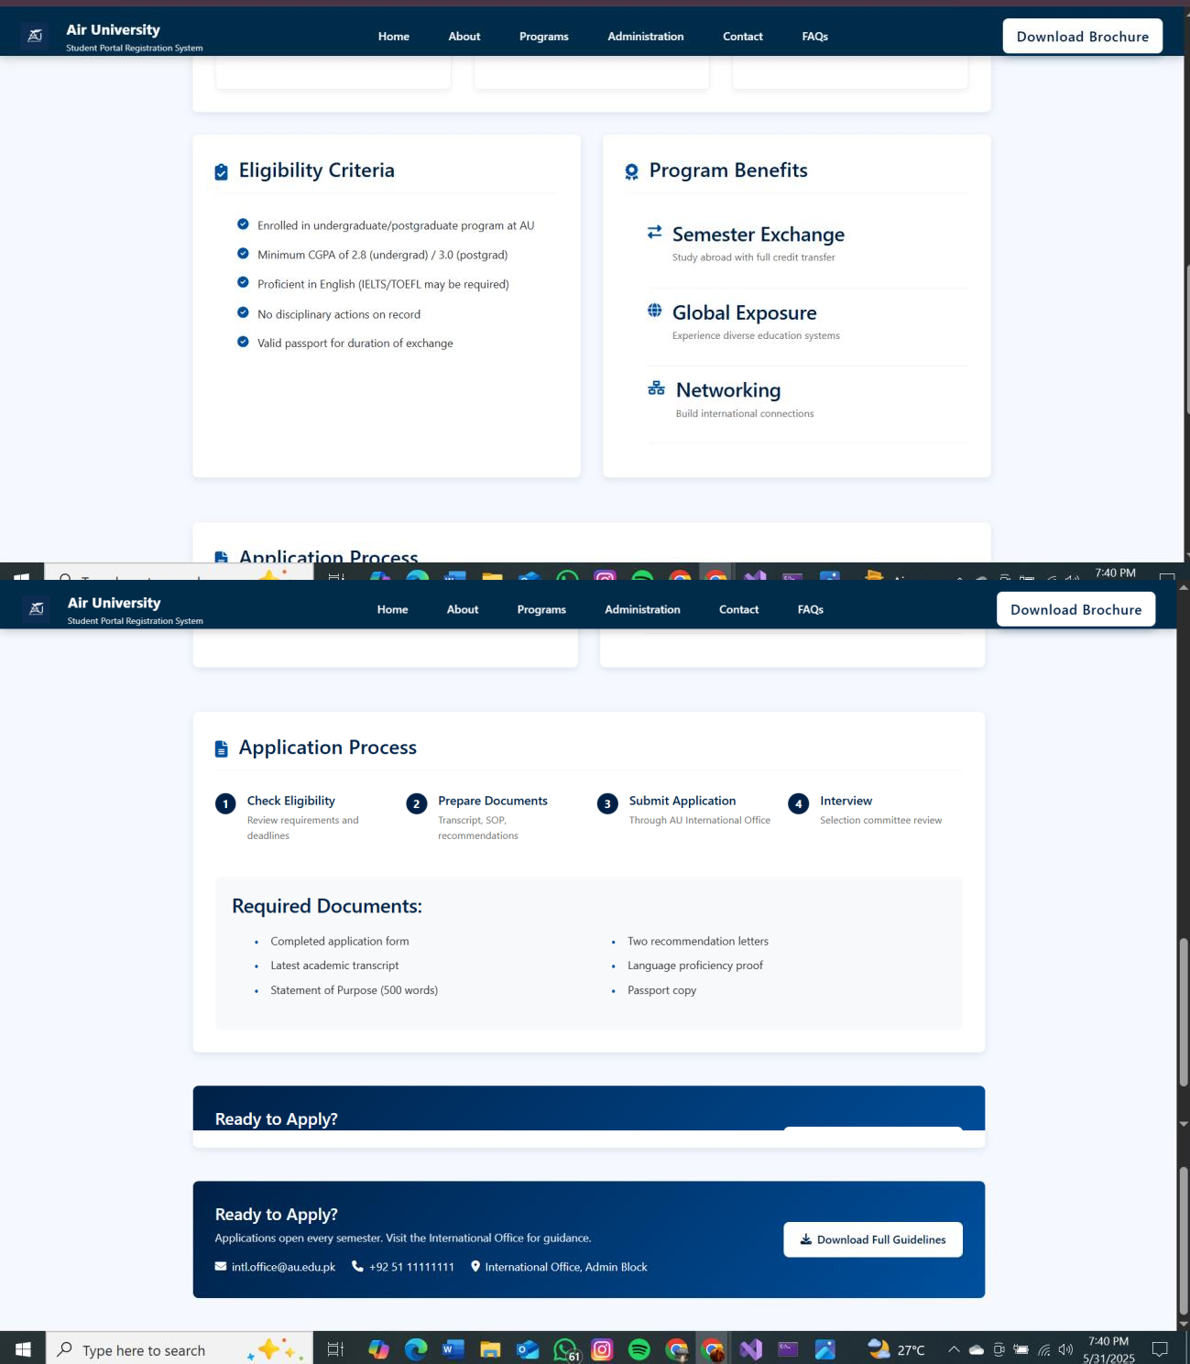

1. **Announcements:**

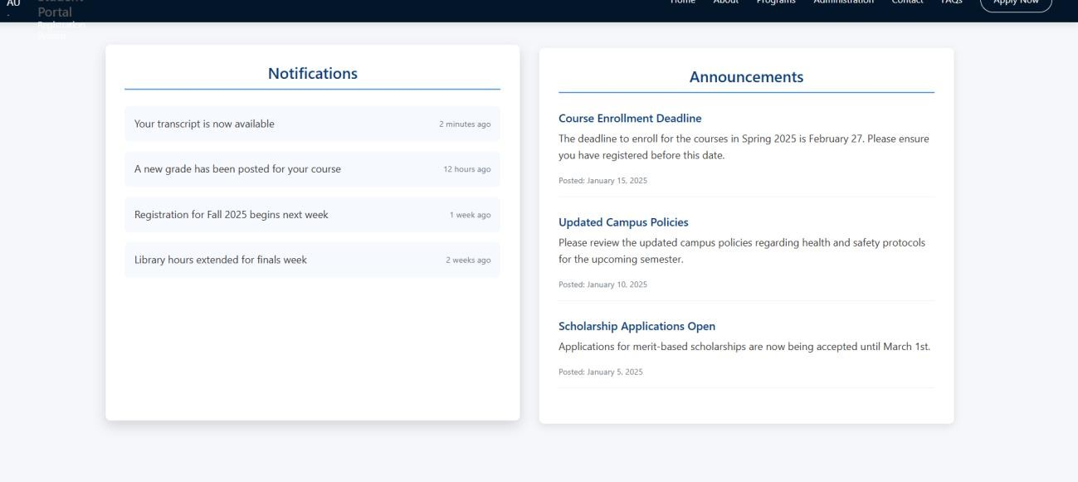

1. **Feedback and Complaints:**

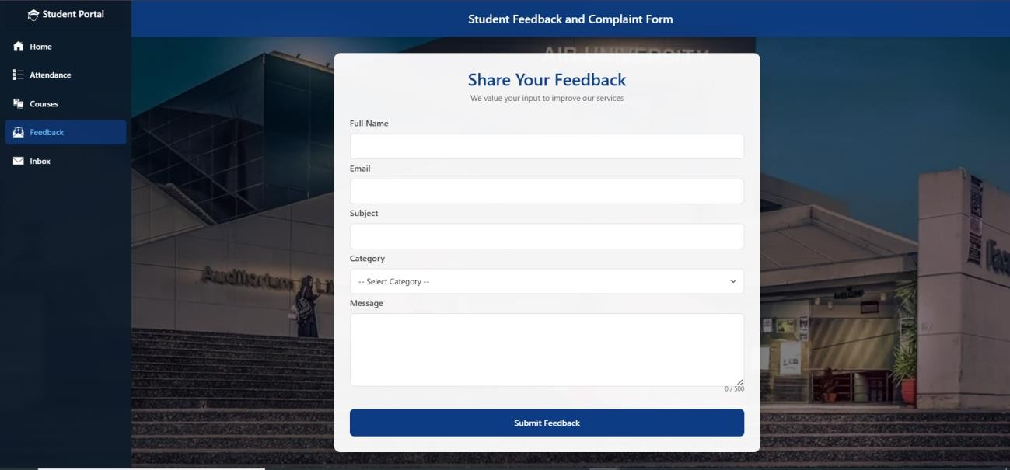

1. **Socities and Clubs:**

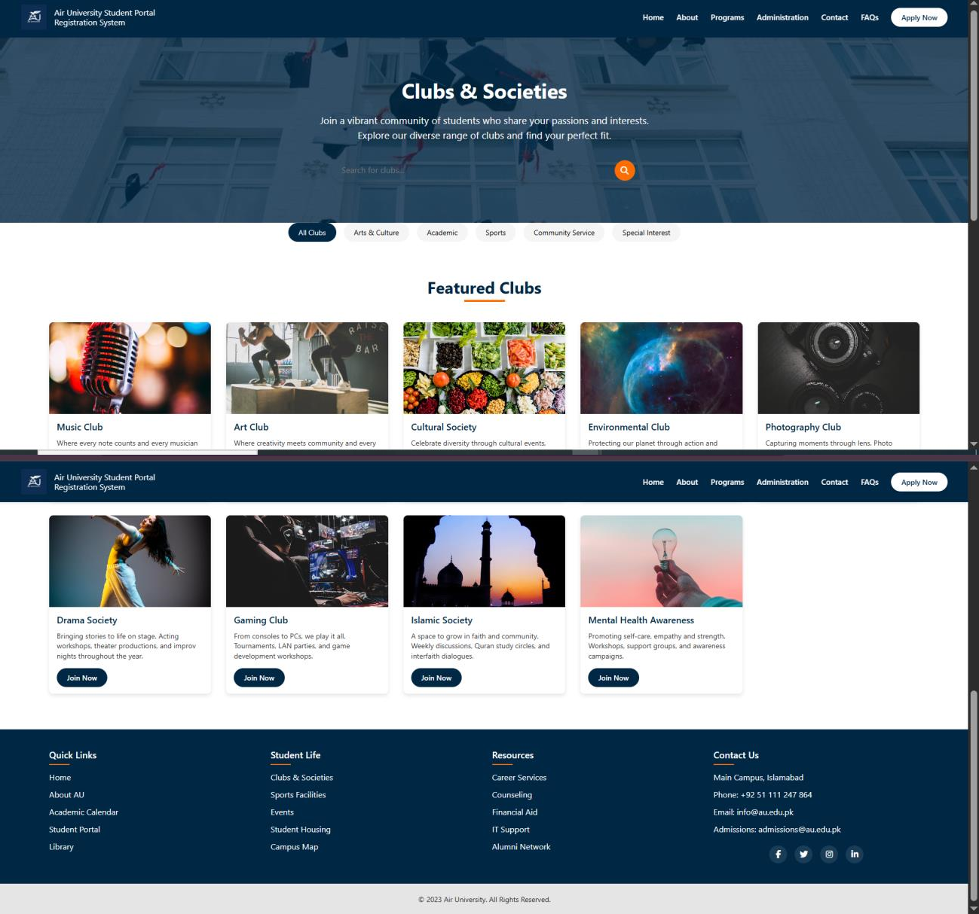

1. **Inbox**

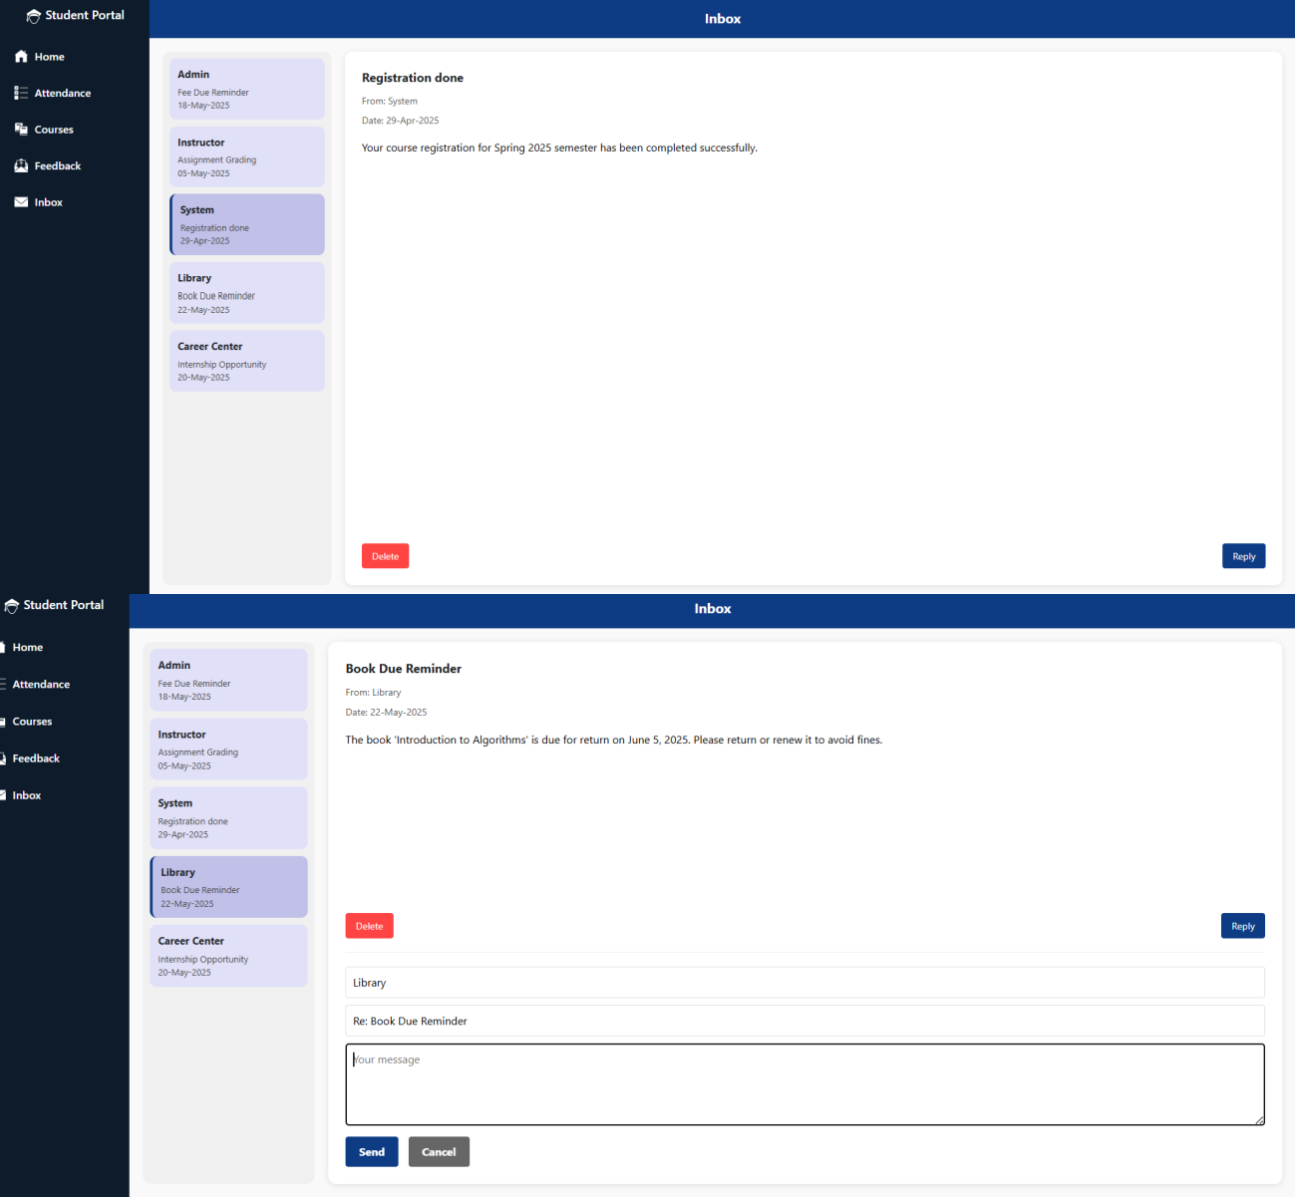

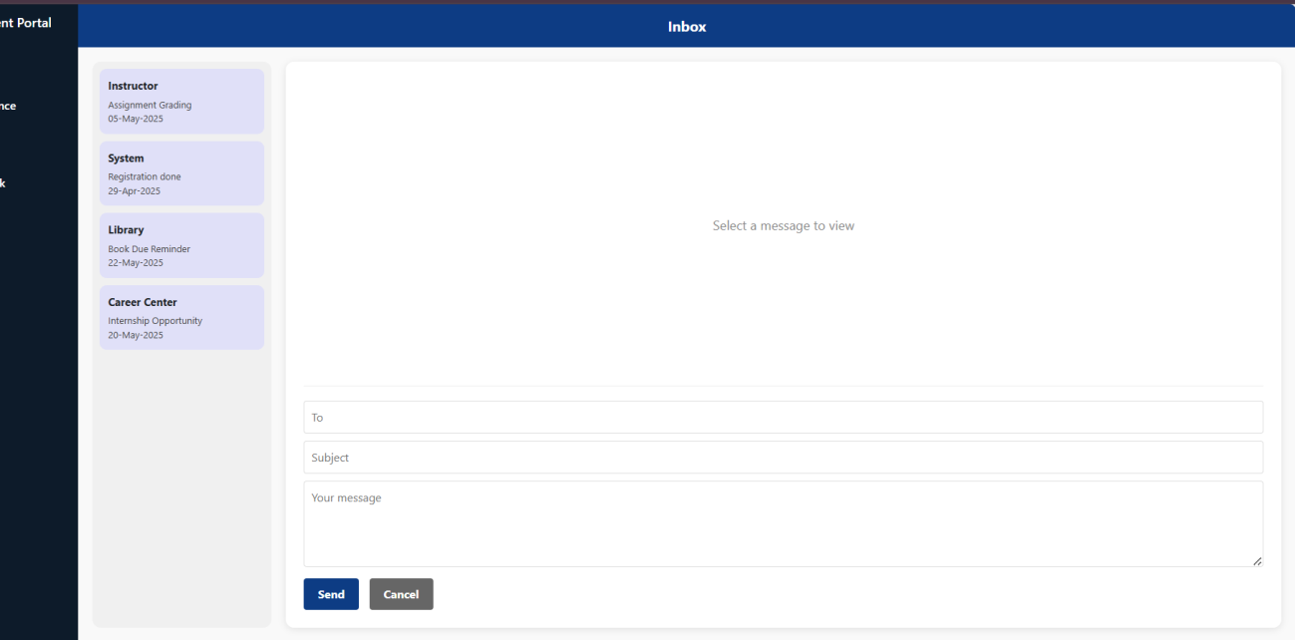

1. **CHAT AI:**

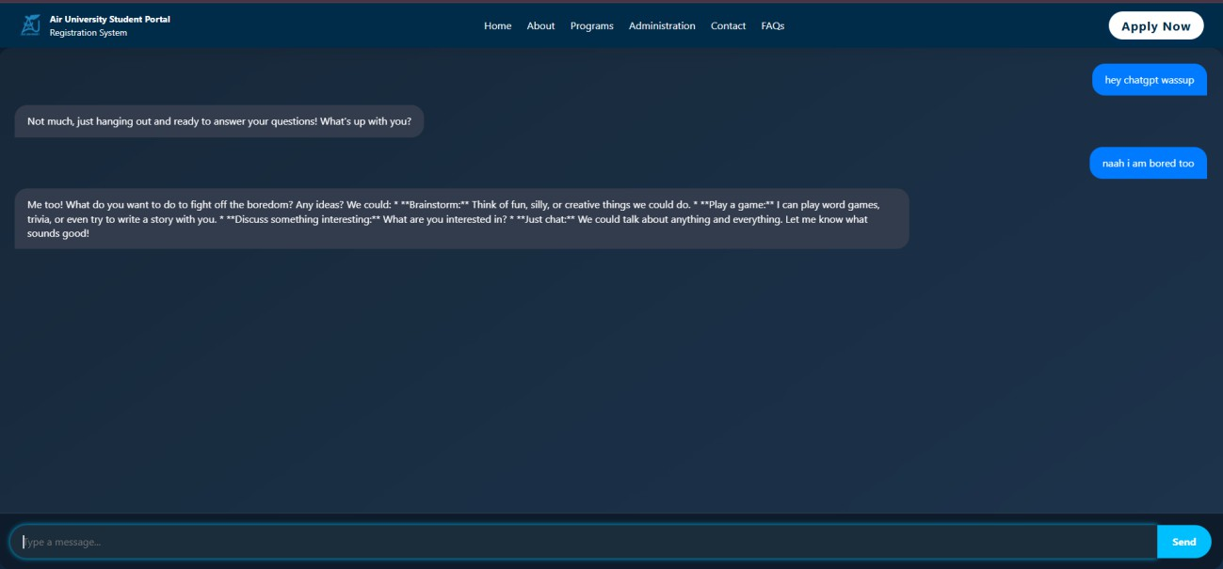

1. **UNDERGRADUATE PROGRAMS:**

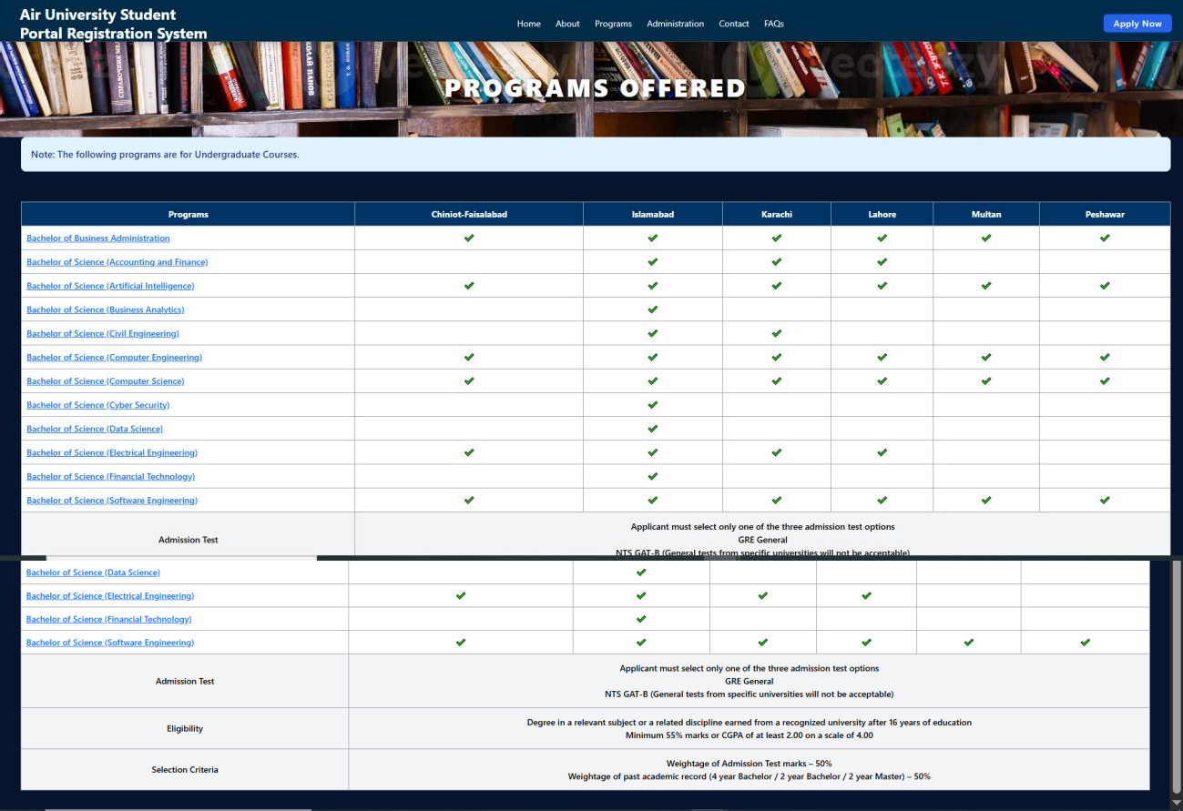

1. **POST GRADUATE PROGRAMS**

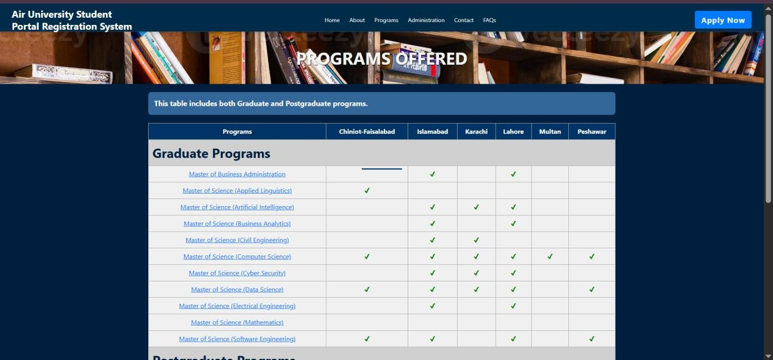

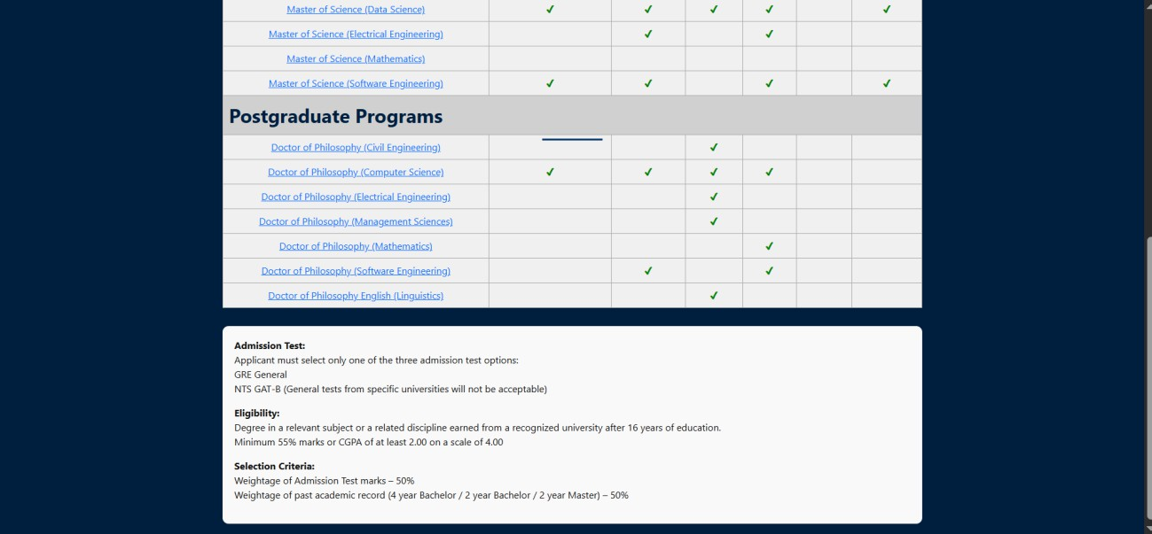

1. **FORMS:**

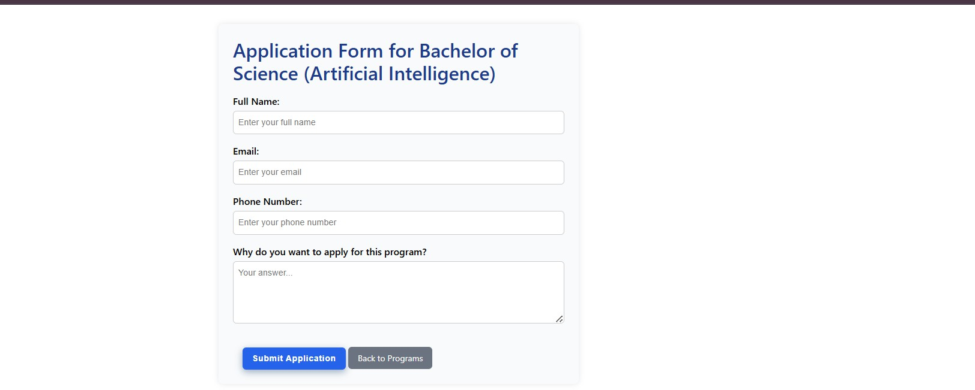

1. **GMAIL PAGE:**

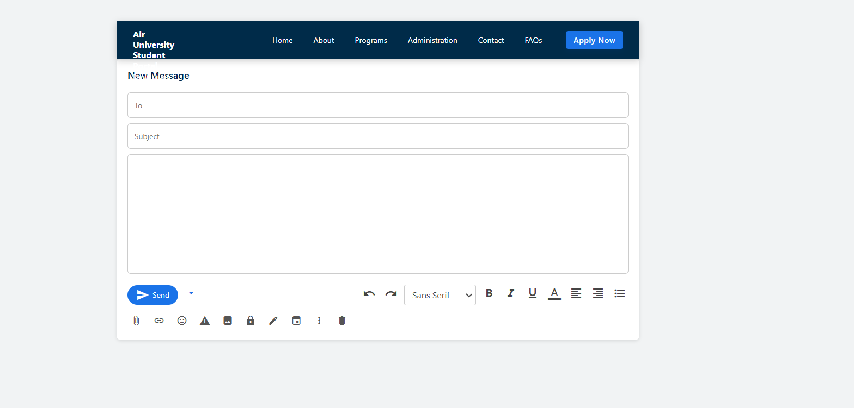

**24. FAQ PAGE:**

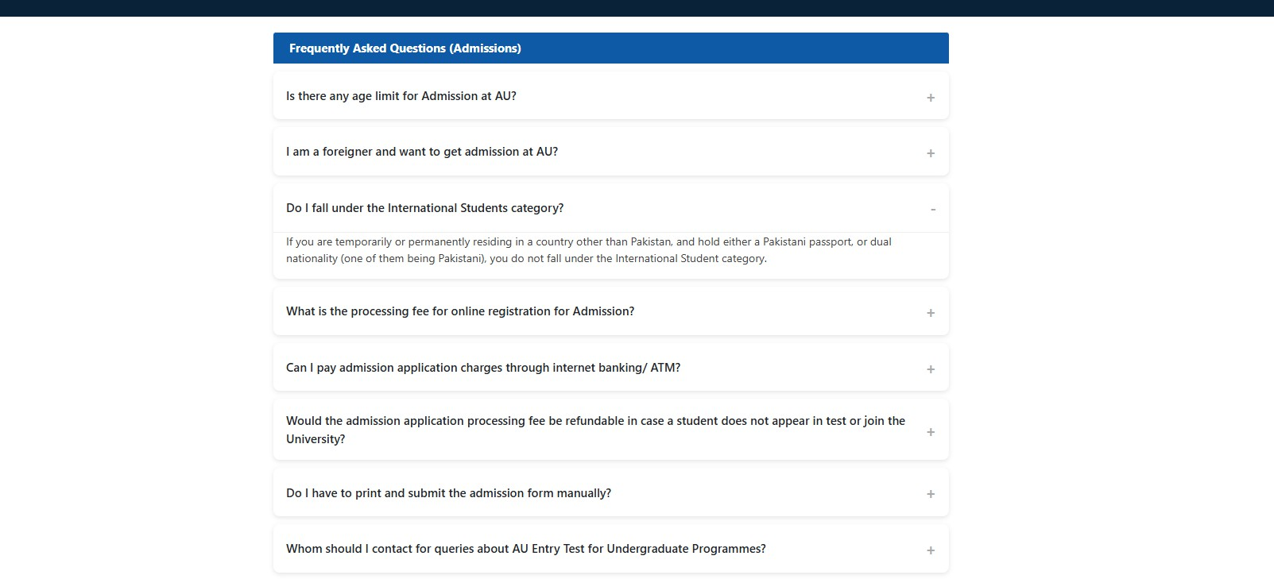

# SERVICES

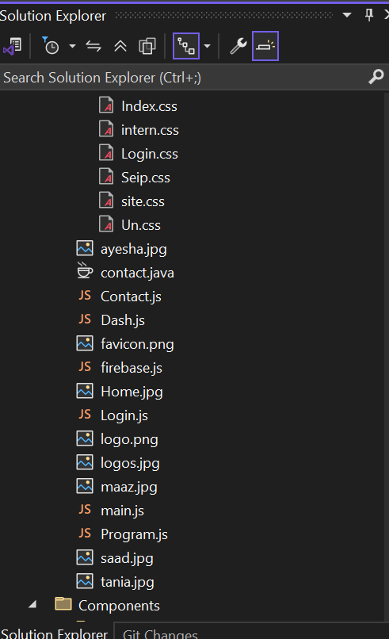 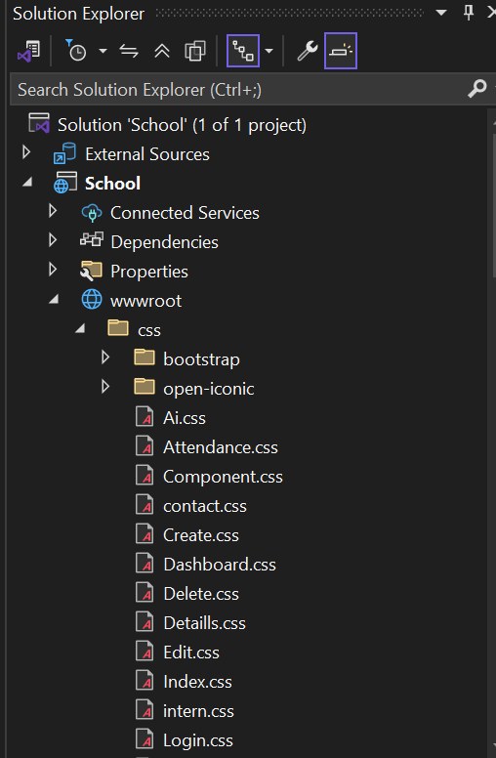

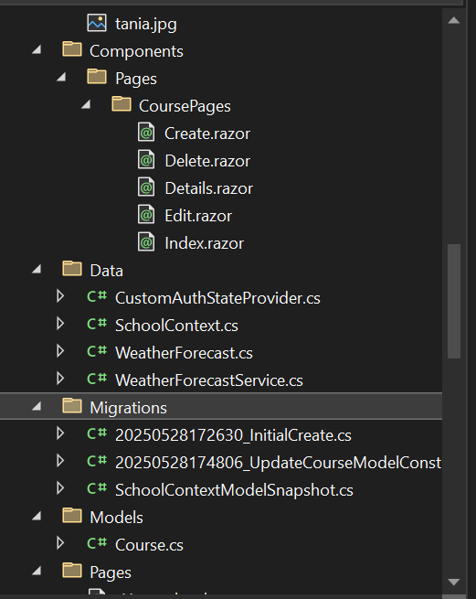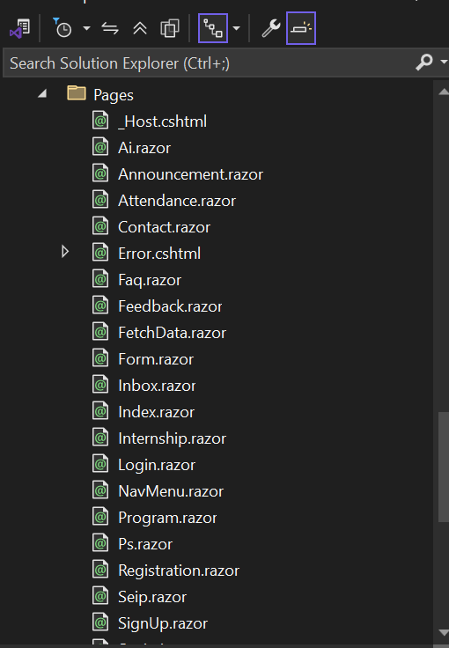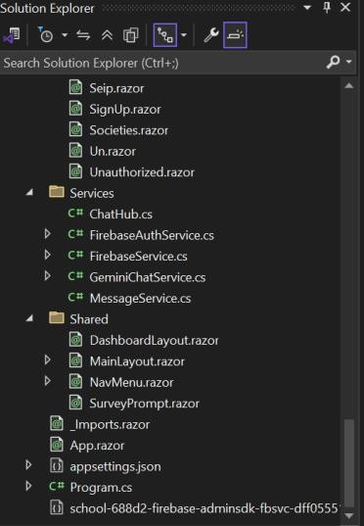

**FIREBASE**

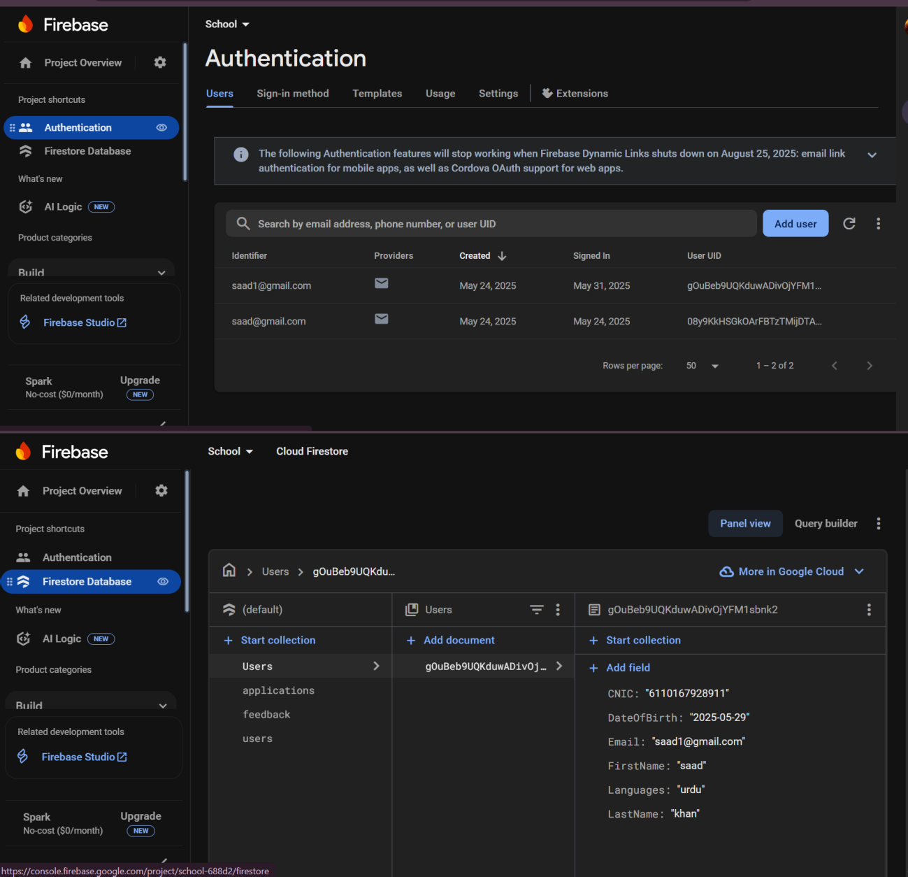

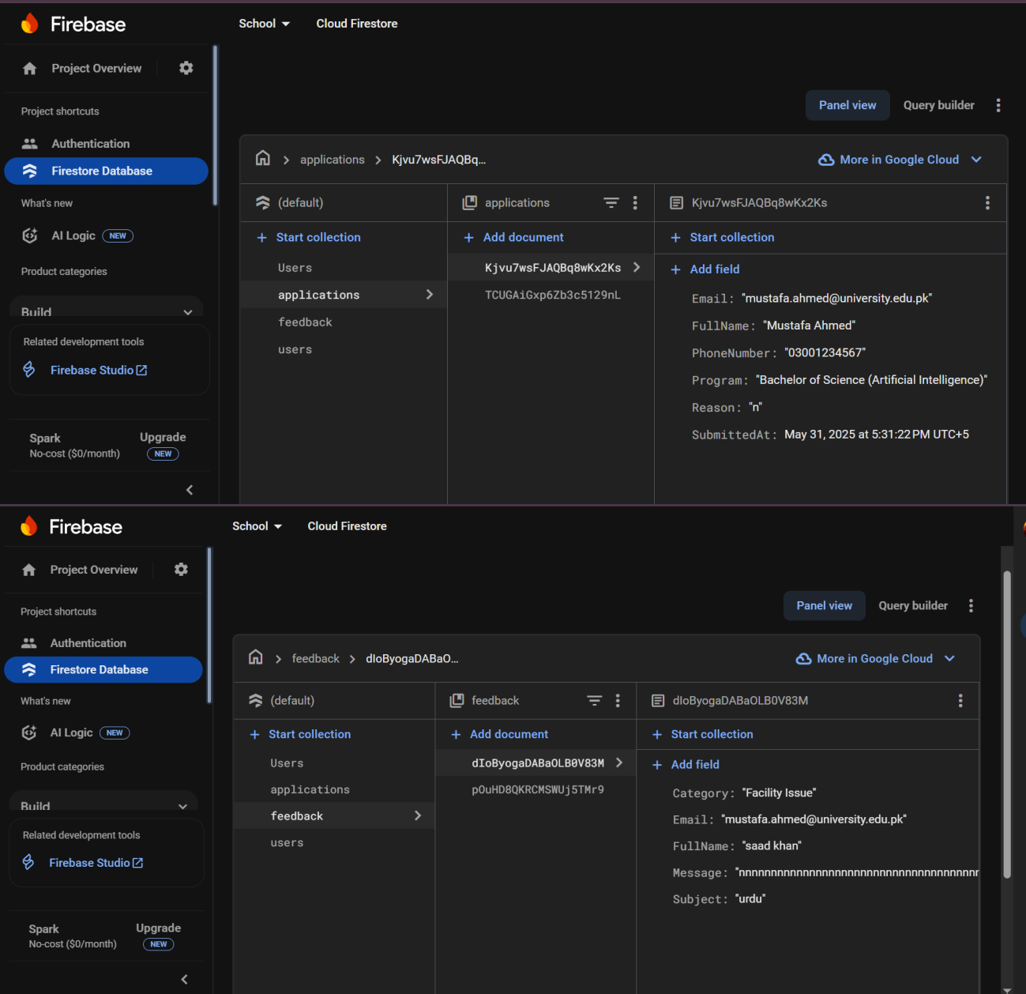

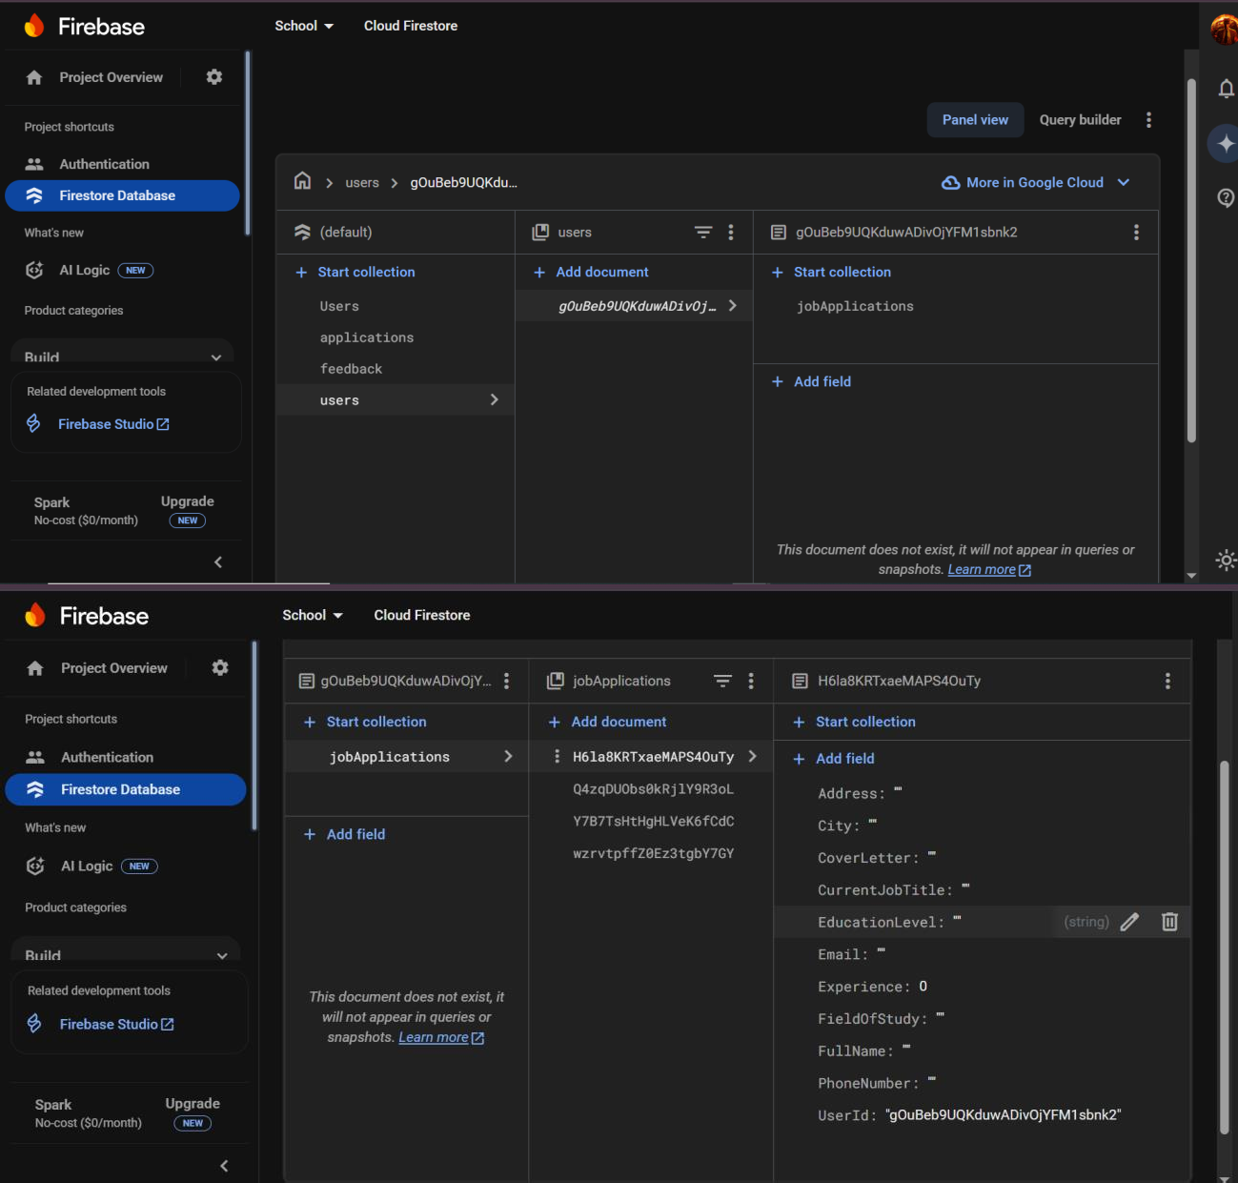

**SQL SERVER:**

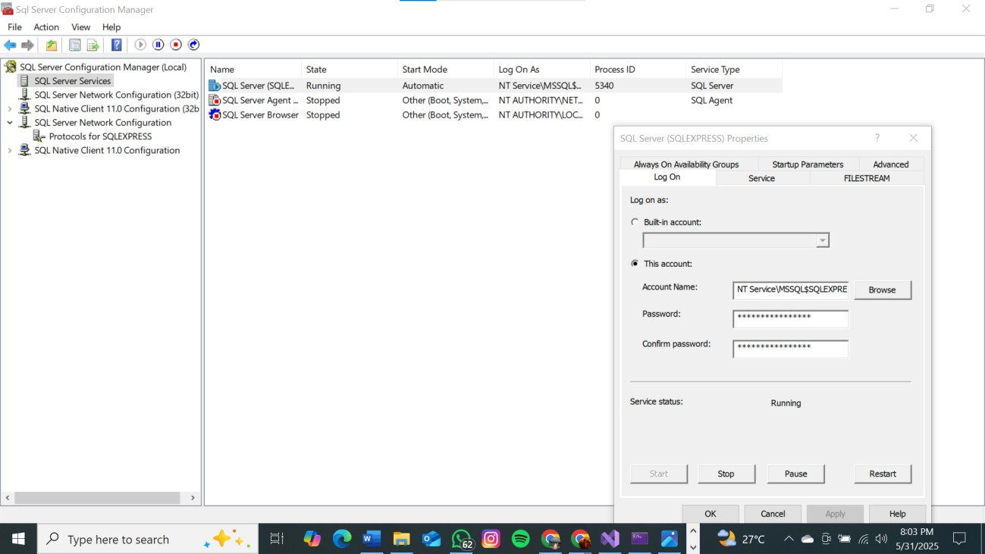

**API FOR CHATGPT:**

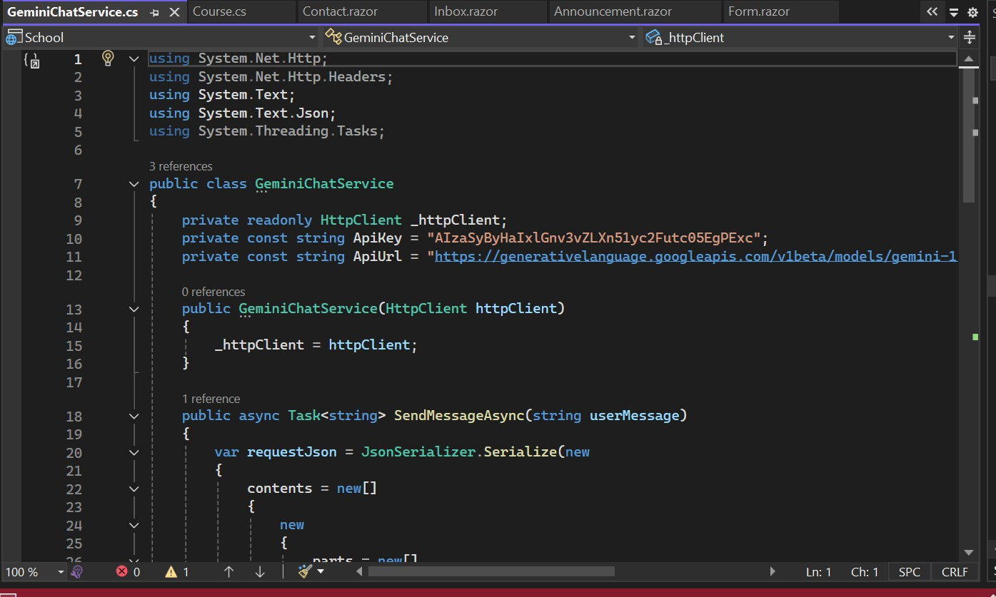

**GOOGLE ANALYTICS:**

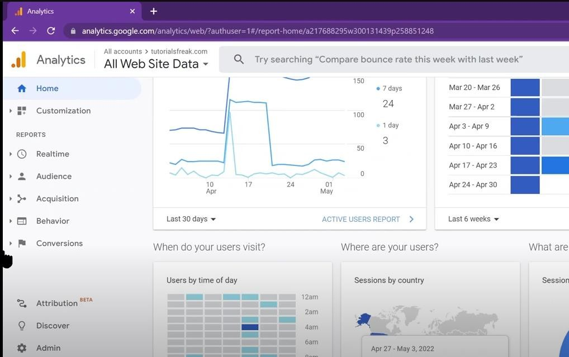

**SSMS (SQL SERVER MANAGEMENT SYSTEM)**

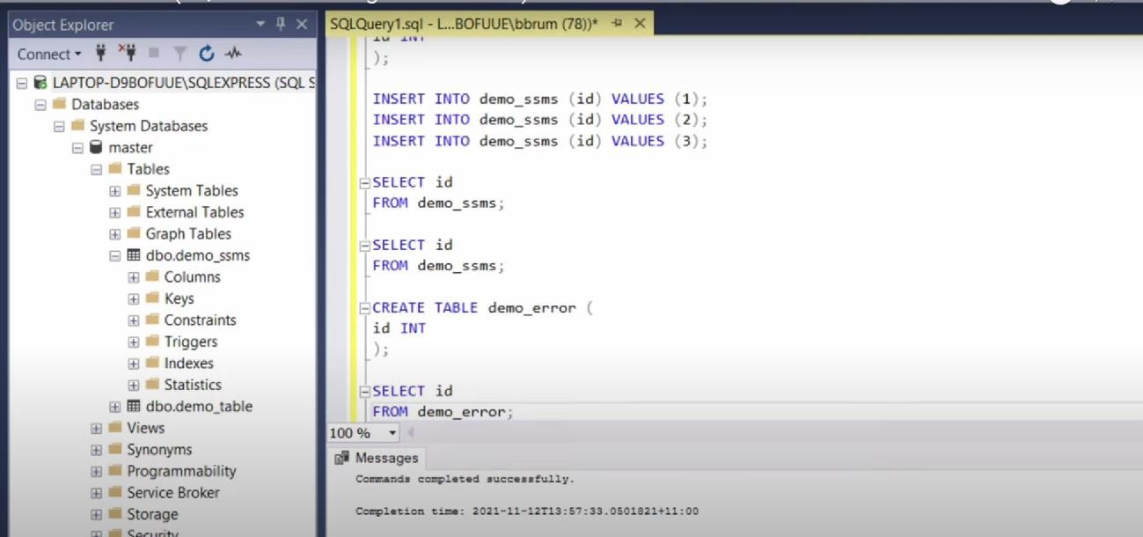

**CONCLUSION:**

The **Air University Student Portal** is a scalable, feature-rich platform that addresses critical challenges in student management. By integrating AI, real-time communication, and automated workflows, it sets a benchmark for future

educational tools. Adherence to **SOLID principles** ensures robust performance, while user-centric design enhances accessibility.